4/20/2020

James Dwyer, Michael Fielder, David Gravett

Lockheed martin (Rebecca broadway, tanner lindbloom)

EVERGLADES

Game Development for Reinforcement Learning

Table of Contents

**Executive Summary3**

**Game Description4**

**Project Description5**

Motivations5

Goals and Objectives6

Function6

Criteria and Constraints6

Broader Impacts6

**Specifications** **and** **Requirements8**

**Block Diagrams10**

**Budget12**

**Project Milestones13**

**Technical Specifications15**

Code Base Characterization15

Purpose15

Deliverable15

Unreal16

Python Structure17

Python Class Diagram19

Python Classes21

Game Telemetry Data30

Explanation of Telemetry30

Procedurally Generated Game Board34

Implementation Ideas34

Chosen Method Overview37

Unreal Engine Rendering53

Wind Effects with Seeded Stochasticity58

Wind Physics Overview58

Stochastic Seeding59

Table of Contents

Relevant Existing Code60

Recreating the Game Board61

Perlin Noise62

Vector Field64

High Level Implementation67

Data Structure Implementation68

Entire Process of Wind Data Structure Generation70

Unit with Sensor71

Purpose71

Sensor Background Research71

Infrared71

Electro-Optical73

Synthetic Aperture Radar73

Sensor Choice75

Back-end Functionality76

Front-end Functionality78

Simulating Thermal Data80

Simulating Reflectance80

Sensor Configuration86

Thermal Image86

Cost/Benefit of Reacting to Sensor Data88

Player Selection of Drone Types89

**Testing92**

Unit, Integration, and Functional Testing92

Testing Strategy93

Performed Unit Testing94

**References95**

Executive Summary

Project Everglades is a game developed by Lockheed Martin as a tool to help teach reinforcement learning for artificial intelligence. This game consists of a Python based game server and an Unreal Engine post processer to view the completed game. For our project, we were tasked with improving upon this game by adding more advanced features, such as a randomized game board and wind effects, as well as preparing the game for future improvements by characterizing the codebase and creating the base for new units.

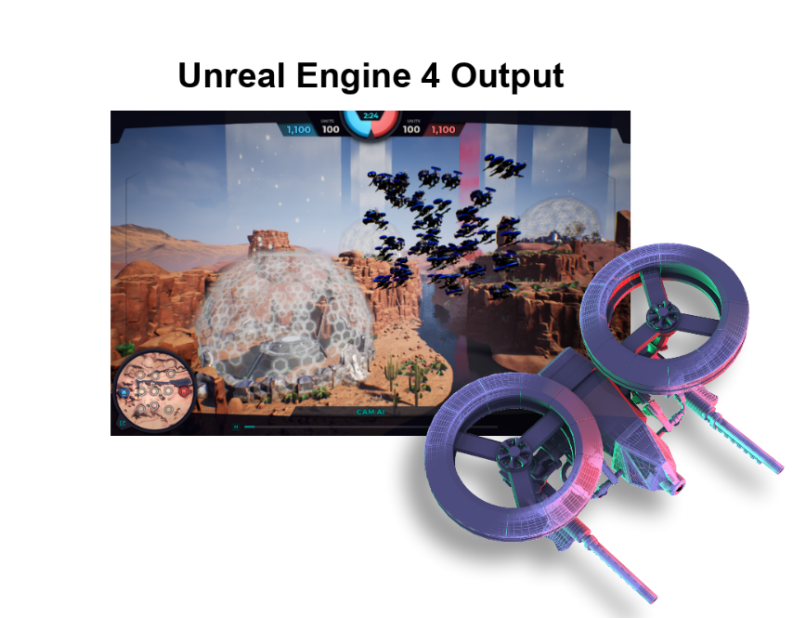

Figure 1: Unreal Engine 4 Output

Game Description

Rules

Project Everglades is played by two opposing AI Agents. Each agent has a starting base that they must defend while also attempting to capture the opponents base. The default map consists of a 3x3 layout of nodes between these two starting bases that the drones must travel between to reach to opposing base. Each of these inner nodes can also be captured which will award that player with points depending on which node was captured. Some of these inner nodes will have special bonuses for the player who controls the node. Some inner nodes will also be either a watchtower or a fortress. A watchtower node will allow the controlling player further vision across the map. A fortress node will give the controlling player’s defending drones a boost in their defense to help during combat.

At the start of each game, both players will begin with 100 drones split into several different groups. The players can use these drone groups to traverse around the map to capture nodes and accumulate points. If drone groups from opposing players meet on the same node, they will battle for that node. There are 3 types of drone units these groups can contain: controller, striker, and tank. Each drone type has different properties allowing for complex strategy development. A striker has increased movement speed and damage but decreased armor, a controller has increased capture speed for nodes, and a tank has increased armor. The game consists of 150 turns where each player can move up to 7 drone groups per turn.

There are 3 possible ways a player can win: the player captures the opposing player’s starting base, the player destroys all the opposing player’s drones, or the player has more points than the opposing player at the end of the 150 turns.

Structure

Project Everglades consists of a Python based game server and an Unreal Engine post processor to view the completed game. Unlike other popular video games, this game executes completely before displaying any of the visuals to view the game in action. The game logic is completely processed by the Python game server, which outputs telemetry data to be used by the Unreal Engine game client to visualize the match. This telemetry data includes information such as the drone unit group compositions, drone group movements, and the player’s point totals after each turn.

Project Description

Motivations

## James

As someone who enjoys gaming in his spare time, the thought of game development has always been appealing. I saw this project as an opportunity to expand my understanding of the Unreal Engine and to develop a game that exceeds the expectations of the sponsor. Given that we are expanding upon an existing codebase, the chance to read, understand, and document the existing program mirrors tasks that can be expected of developers throughout their career. Working on a project that uses Docker containers and reinforcement learning also introduce me to new aspects of development that I hope will improve my capabilities as a software engineer.

David

My interest in programming first began in Middle School when I used to play a game called Roblox. This game allowed you to create your own games using 3D map design and LUA based programming. Playing this game and creating my own games began my overall interest in pursuing programming as a career. Once I entered High School, I took a Game Development class which helped me learn the basics of game design and implementation. After taking this class, I took many other programming related classes over the next 3 years that allowed me to create Windows and Android based Java games. Ever since these earlier times in my academic career I have been interested in the prospects of a career in Game Development and have now been given a chance to practice in this area of computer science.

Michael

I’ve been playing video games since I was a toddler and have been playing games ever since, so it was a no brainer to choose a project that focuses on game development. I also understand the general process of creating a game from a Unity game development course I took in my Senior year of high school. My other motivation for completing this project is learning Unreal Engine 4, which is an important software to learn. The final motivation that I have for completing this project is to learn how to create software that aids in the machine learning process. Machine learning is one of the most sought-after skills in the programming field, and any project that helps you improve those skills is beneficial. Overall, I feel that I am very motivated to produce my best work on this project.

# 

Project Description

# Goals and Objectives

The overall goal of our project is to further develop the EVERGLADES AI training application by characterizing the code, adding procedurally generated game boards, and to finally add stochastically seeded wind. In order to achieve a truly procedurally generated game board, the application should be able to create game boards with varying amounts of nodes, connections between those nodes, and structures. As for the wind, it should be able to also produces varying orientations.

Function

The EVERGLADES project is an artificial intelligence game that facilitates AI training and research and through a turn-based game board that controls multiple drone swarms. The purpose of the game portion is to create a playground for training both teams while also providing a graphical representation of the game space through post-processing in Unreal Engine. The actual server for the game is contained in the application Docker, and this is where the AI’s are trained.

# Criteria and Constraints

The constraints of our project include incorporating the current Docker environment for the game server as it is the entity that is providing the telemetry output data that is used for post-processing. As for the post-processing itself, that must be developed using the architecture that was already created using Unreal Engine.

# 

# Broader Impacts

Due to the nature of the game, a possible global impact from the results of this project is its influence on national security. Military drones are an integral part of contemporary warfare, and they become more important as technology becomes more advanced. Our project directly satisfies the goals of improving the high-level decision-making of drones against a sophisticated and constantly changing enemy. National security involves conflict that is spontaneous, and it requires technology that can react quickly and efficiently. Therefore, it is safe to say that our project could have an impact on national security by possibly improving the way that drones assess impending threats.

Project Description

A more local impact that our technology could have is within Lockheed Martin itself. The data the EVERGLADES Project collects can be used to advance drone technology by serving as a data set that can drive further developments in the right direction. It could also spark new machine learning development if there are any interesting unexpected discoveries that come from our project. Indeed, our project could provide Lockheed Martin invaluable high-level information that they could use for analysis. The code on its own is also highly scalable and could be expanded on to include elements such as a more sophisticated map and a fully 3-D movement system in order to more closely simulate real-life drone combat.

The last and most plausible broader impact of this project is to be used as an effective machine learning teaching tool. The entire project is set up to facilitate this from the entire being open-source to the program favoring AI gameplay over even simple human gameplay., Indeed, the program could be a valuable teaching asset to everything from a college student to an AI hobbyist. It’s effectiveness as a teaching tool should only augment as the application becomes more robust.

# Specifications and Requirements

|  |  |
| --- | --- |
| ID | Description |
| Characterize Codebase | |
| 101 | Each class will have a short description of what it is and its purpose |
| 102 | Each major function will have a description of its purpose |
| 103 | Each major function’s parameters will have a description and include their constraints |
| 104 | Each major function will have a description of its output and the output’s constraints |
| 105 | Diagrams of class interactions will be created |
| 106 | There will be an overview of how matches are run by the user |
| 107 | There will be an overview of how file paths must be set |
| Procedural Generation of Game Board | |
| 201 | Game board will not exceed 50 nodes in size, excluding the two home bases |
| 202 | Game board will be randomly generated |
| 203 | Procedural generation of game board will be seeded |
| 204 | Game board will be valid, meaning there is at least one travelable, valid path from one home base to the other |
| 205 | Game will present user with option to choose a game board that is either “fair” or “unfair” |
| 206 | A “fair” game board will be symmetrical, ensuring that the same number of nodes will be passed through when traveling similar paths from either home base and ending at the opposite home base |
| 207 | A breadth first search will be used to generate the valid, random game board |
| 208 | The user will choose a weight to determine the density of node clusters |
| 209 | An “unfair” game board will favor one of the opposing teams by providing the advantage of having more neutral nodes near their home base |
| Wind Effects | |
| 301 | Wind will be stochastic |
| 302 | Stochasticity will be seeded |
| 303 | Wind will affect swarms’ ability to travel |
| 304 | Wind will visibly affect the scene in the game graphics |
| 305 | Wind will utilize vectors, specifically their x and y components to calculate the effect on swarm movement |

# Specifications and Requirements

|  |  |
| --- | --- |
| RL Algorithm Training | |
| 401 | RL algorithm is affected by playing the game |
| 402 | RL algorithm can be trained by replaying the game |
| Drone Death Animation | |
| 501 | Drones will explode when destroyed |
| 502 | Explosion will be proportional to drone size |
| 503 | Explosion animation will replace the drone asset |
| New Unit Class | |
| 601 | New unit class will have an attached sensor |
| 602 | Sensor will be infrared |
| 603 | Unit sensor will appropriately affect gameplay |
| 604 | New unit will have unique abilities compared to other units |
| 605 | Sensor properties can be configured by the agents |
| 606 | Unit will be visually unique compared to other units in Unreal |
| 607 | Unreal game objects will have a temperature |
| 608 | Unreal game objects will have an infrared reflectance property |
| 609 | Reflectance values will be as close to realistic as possible |
| 610 | Unreal game objects will have reflectance property based on USGS data |
| 611 | A thermal image effect will be available in Unreal |

Table 1: Everglades requirements

Block Diagrams

* Overall Game Process, all components currently exist, and we will be improving the Game Server and Unreal Engine Graphics Post Processing. 

Figure 2: Overall Block Diagram

Block Diagrams

* Project Goals

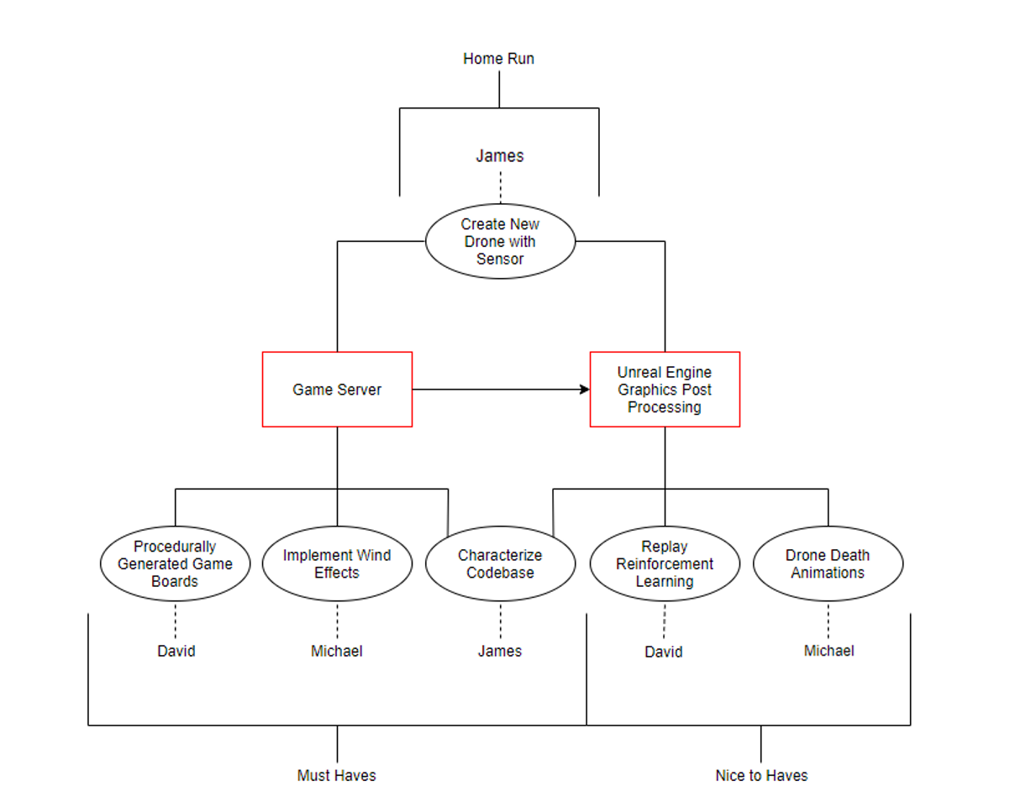

Figure 3: Project Goals Block Diagram

Budget

This project did not require us to purchase any software. The main applications we used were Unreal Engine 4 and Visual Studio, both of which are free. Due to the large file size of the Unreal Engine game client, we were required to purchase a Github Large File Storage subscription so that we could version control the main project folder.

* Software Required:
  + Unreal Engine 4 (Free)
  + Visual Studio Community 2017/2019 (Free)
* Services Used:
  + Github LFS ($5/Month - $15 total)



Figure 4: Unreal Engine Logo



Figure 5: Visual Studio Logo

Figure 6: GitHub Logo

Figure 7: Blender Logo

Project Milestones

|  |  |  |  |
| --- | --- | --- | --- |
| No. | Task | Due | Status |
| Senior Design I (research, documentation, design) | | | |
| 1 | Project Kickoff | 9/24/2019 | Complete |
| 2 | Learn UE4 | Ongoing | In Progress |
| 3 | Initial Design Document | 10/2/2019 | Complete |
| 4 | TA Meeting I | 10/5/2019 | Complete |
| 5 | Research Ideas for Implementation | 10/13/2019 | Complete |
| 6 | Prof. Heinrich Meeting | 10/16/2019 | Complete |
| 7 | Broad Understanding of Existing Codebase | 10/23/2019 | Complete |
| 8 | Lockheed Meeting | 10/30/2019 | Complete |
| 9 | Edit Document w/ Sponsor Feedback | 11/3/2019 | Complete |
| 10 | TA Meeting II | 11/11/2019 | Complete |
| 11 | Edit Document w/ TA Suggestions | 11/17/2019 | Complete |
| 12 | Design Document Editing | 12/1/2019 | Complete |
| 13 | Final Design Document | 12/5/2019 | Complete |

Table 2: Project Milestones for Senior Design I

Project Milestones

|  |  |  |  |
| --- | --- | --- | --- |
| No. | Task | Due | Status |
| Senior Design II (implementation) | | | |
| 1 | Prof. Heinrich Meeting | 1/15/2020 | Complete |
| 2 | Random Game Board Python Code Complete | 1/20/2020 | Complete |
| 3 | Major Bugs Fixed | 2/3/2020 | Complete |
| 4 | Python Codebase Characterized | 2/3/2020 | Complete |
| 5 | Critical Design Review Presentation | 2/10/2020 | Complete |
| 6 | Random Game Board Unreal Code Complete | 2/24/2020 | Complete |
| 7 | Unreal Game Client Codebase Characterized | 3/12/2020 | Complete |
| 8 | New Drone Unit Python Code Complete | 3/23/2020 | Complete |
| 9 | Prof. Heinrich Zoom Demo | 4/2/2020 | Complete |
| 10 | Wind Effects Implemented | 4/18/2020 | Complete |
| 11 | New Drone Unit Unreal Code Complete | 4/18/2020 | Complete |
| 12 | Project Presentation | 4/20/2020 | Complete |

Table 3: Project Milestones for Senior Design 2

Code Base Characterization

Purpose

Characterizing the code base of the previous iteration of Everglades: Game Development will give us a thorough understanding of how the existing classes and procedures affect the overall flow of the game. Understanding the current structure of the game is critical to effectively integrate our improvements and additions.

This also serves as a valuable learning experience. Most developers work with completed code that they alter or expand, rather than coding from scratch. They may even be tasked with characterizing a code base a few times throughout their career.

Deliverable

Both the Python and the Unreal codebase characterizations are presented as Markdown files. This format made it easy to edit and link together files. The HTML output from the Markdown files looks clean and professional. Separate files exist for each class and method as well as sections for events, event dispatchers, and macros for Unreal. Markdown Editor extension for Visual Studio was used to visualize the output as the files were being created. Examples of the Python codebase deliverable can be seen in Fig. and Fig.

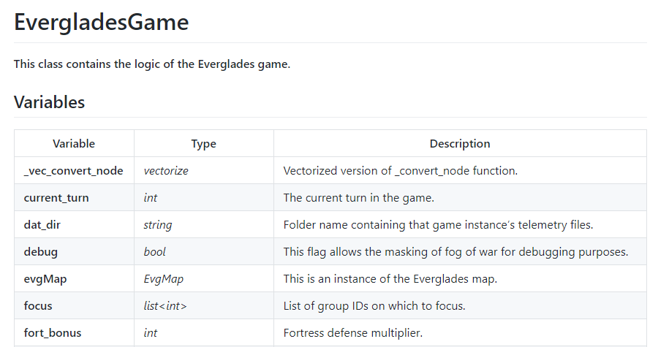

Figure 8: Partial example of Python class deliverable showing the variables

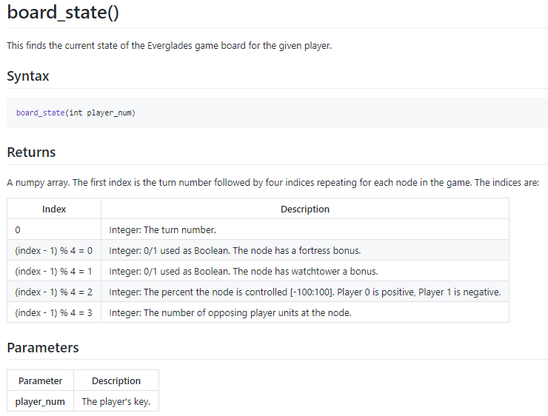

Figure 9: Deliverable example showing a Python method

Unreal

The Unreal portion of the project made extensive use of Unreal blueprints. Given the visual nature of much of the data, especially regarding the various HUDs there are many more variables and methods for the client versus the server. Therefore, these items will not be presented in this paper, but can be seen in the deliverables. Visual tracing was used to decipher the blueprints. Methods, events, event dispatchers, and macros all share a similar format, which is slightly different than the format used for the Python files due to the nature of blueprint nodes (Fig. ). It must also be noted that despite initially wanting to include images of the respective node in the Markdown file, this was not accomplished due to time constraints.

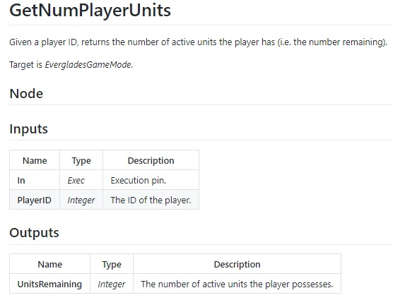

Figure 10: Example of deliverable for Unreal method. Events, event dispatchers, and macros have the same format.

Python Structure

As shown in the overall game process block diagram (see figure X), the game’s environment exists on the server and the menu and post-processed graphics are on the client. Users can choose to view an existing telemetry file or to play a match between two AI agents on the server (see figure 1).



*Figure 11: Everglades menu showing choice of telemetry or server*

Code Base Characterization

The code for the game logic is composed of python files which are separated into different folders depending on the function as shown in figure 2.



Figure 12: Files and folders contained in Everglades

The *agents* folder contains python files that dictate the logic of an AI agent. There are three default programs within, but users can create and save their own to the folder. Then, their script can be selected and used in an Everglades match.

The *config* folder has four JSON files used to configure the game during initialization. They provide data for the initialization of the map, game, players, and units. The values can be altered if a user wishes to customize their Everglades match, but some changes may cause errors.

The game logic is within the *everglades-server* folder. It has two Python files: one containing server logic, the other with initializations for various classes in the game.

As Everglades matches run, they output data that is stored in the *game_telemetry* folder. This data can be used to provide insight for different areas of the match and for use by Unreal Engine to provide post-processed visualizations.

The *gym-everglades* folder contains the OpenAI Gym for Everglades. It is a Python file that initializes the game with the AI agents and sets up the observation and action spaces.

The *.gitignore* file is used by version control to ignore changes to certain files. While any file can be included, it currently ignores compiled files and telemetry output.

*README* is a markdown file containing information related to the installation of Everglades. It also contains descriptions of the folders’ contents.

Code Base Characterization

*SeniorDesignDocument* is this file.

Finally, *test_battle* is a Python script that runs two agents against each other in an Everglades match.

Python Class Diagram

This shows an overview of class associations regarding which class is responsible for the other. Child classes point to the parent.

The main script, *test_battle.py*,constructs the OpenAI Gym from *EvergladesEnv*, the class containing the information on the Everglades environment. *EvergladesEnv* creates an instance of *EvergladesGame* (see figure X). Note that *GameSetup.json* contains configuration data for an Everglades match, but the game does not use this file, currently. *EvergladesEnv* also contains data for players, but this is information on the AI agents, not the *EvgPlayer* class.

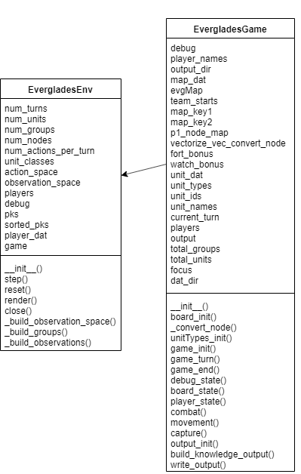

Figure 13: EvergladesEnv contains EvergladesGame

Code Base Characterization

*EvergladesGame* creates instances of the *EvgMap*, *EvgPlayer*, and *EvgUnitDefinition* classes (see figure X). It passes information from *DemoMap.json* to *EvgMap* to instantiate the map and *UnitDefinitions.json* to *EvgUnitDefinition* to instantiate the unit types. Note that *PlayerConfig.json* contains some data on a player’s group compositions, but this file is not currently used.

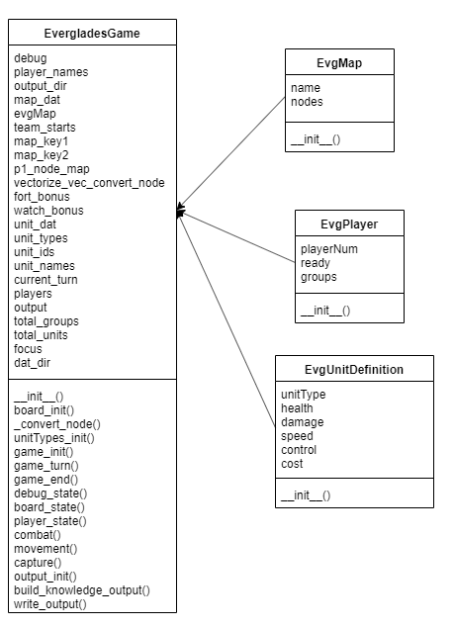

Figure 14: EvergladesGame contains EvgMap, EvgPlayer, and EvgUnitDefinition

*EvgMap*, *EvgMapNode*, and *EvgNodeConnection* are instantiated by *EvergladesGame* (see figure X). However, *EvgMapNode* is contained within *EvgMap* and *EvgNodeConnection* is within *EvgMapNode*.

Code Base Characterization

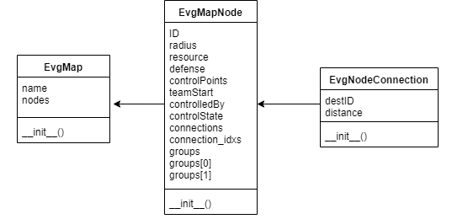

Figure 15: EvgMap contains EvgMapNode. EvgMapNode contains EvgNodeConnection

*EvgPlayer* contains *EvgGroup* and *EvgUnit*, but each are instantiated by *EvergladesGame* (see figure X). *EvgUnit* creates an instance of *EvgUnitDefinition* for each unit in the game and initially contains null values. *EvergladesGame* then replaces these null values with the corresponding actual values contained in its own unit definition instance.

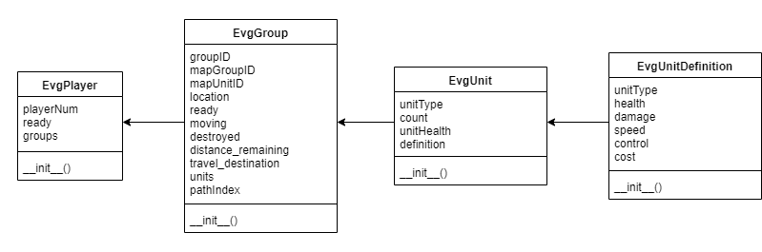

Figure 16: EvgPlayer contains instances of EvgGroup, which contains instances of EvgUnit, which contains an instance of EvgUnitDefinition

Python Classes

What follows is a brief description of the contents of each class including properties and functions. The classes were visually inspected to determine purpose and datatype. *Pyreverse*, a python package that reverse-engineers python code and creates UML diagrams, was used to verify the classes. Its output follows each class. *Pyreverse* could not be used to determine dependencies between classes because the python code was not packaged. Some variables in the *pyreverse* output may also be missing datatypes for variables that store data from a configuration file or another class. A more thorough description of the Everglades classes will be included in a markdown file deliverable.

Code Base Characterization

Note for some properties, *int* or *float* may be listed as the type. Python is dynamically typed, so the types of these variables depends on the data that is passed to them. Some variables have default values that are integers but receive floats from the configuration file.

#### EvgMap in definitions.py

The class of the Everglades map. Its only method is the map initializer. Figure X shows the *pyreverse* class diagram.

Properties:

1. *string* **name**: The name of the map.
2. *list* **nodes**: The list of nodes within the map.

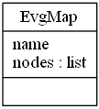

Figure 17: Pyreverse EvgMap output

#### EvgMapNode in definitions.py

The class of the nodes that make up the everglades map. Its only method is the node initializer. Figure X shows the *pyreverse* class diagram.

Properties:

1. *int* **ID**: The identification number of the node.
2. *float* **radius**: The radius of the node.
3. *list* **resource**: A list of the resources for the node. It contains ‘OBSERVE’ for watchtower, ‘DEFENSE’ for fortress, and an empty list for a node with no resources.
4. *int* **defense**: The defense value for the node.
5. *int* **controlPoints**: The amount of points a player receives for controlling the node.
6. *int* **teamStart**: Indicates the node is a team’s home base. It is 0 for player 0, 1 for player 1, and -1 for all neutral nodes.
7. *int* **controlledBy**: Indicates which player controls the node. It uses the same integer values as teamStart.
8. *int* **controlState**: This is the percentage that the node is under control.
9. *list* **connections**: The list of tuples containing valid connections from this node and the respective distances.
10. *list* **connection_idxs**: The list of valid connections from this node.

Code Base Characterization

1. *dict* **groups**: The key is the player number (0 or 1) and the value is a list of group IDs for groups located at this node.

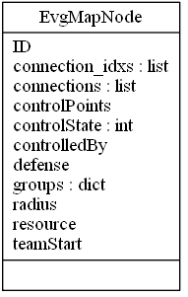

Figure 18: Pyreverse EvgMapNode output

#### EvgNodeConnection in definitions.py

The class of the connection between two nodes. Its only method is the connection initializer. Figure X shows the *pyreverse* class diagram.

Properties:

1. *int* **destID**: The identification number of the destination node.
2. *int* **distance**: The distance to the destination node.

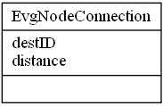

Figure 19: Pyreverse EvgNodeConnection output

#### EvgPlayer in definitions.py

The class of the Everglades player. Its only method is the player initializer. Figure X shows the *pyreverse* class diagram.

Properties:

1. *int* **playerNum**: The identification number for the player.
2. *bool* **ready**: ***This property is never referenced.***
3. *list<EvgGroup>* **groups**: The list of groups belonging to the player.

Code Base Characterization

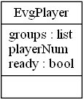

Figure 20: Pyreverse EvgPlayer output

#### EvgGroup in definitions.py

The class of a group of drones, a swarm. Its only method is the group initializer. Figure X shows the *pyreverse* class diagram.

Properties:

1. *int* **groupID**: The identification number for the group.
2. *int* **mapGroupID**: A cumulative group identification for outputting the initial number of groups on the map.
3. *int* **mapUnitID**: A cumulative unit identification for outputting the initial number of units on the map.
4. *int* **location**: The node where the group is located.
5. *bool* **ready**: This indicates if the group is ready to move.
6. *bool* **moving**: This indicates if the group is currently moving.
7. *bool* **destroyed**: This indicates if the group has been destroyed.
8. *int* **distance_remaining**: The remaining distance the group must travel to reach the destination node.
9. *int* **travel_destination**: The node to which the group is traveling.
10. *list<EvgUnit>* **units**: The list of units contained in the group.
11. *int* **pathIndex**: ***This property is never referenced.***

Code Base Characterization

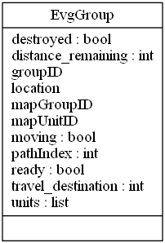

Figure 21: Pyreverse EvgGroup output

#### EvgUnitDefinition in definitions.py

The class of the Everglades drone unit definition. It defines the stats of the unit. Its only method is the unit definition initializer. Figure X shows the *pyreverse* class diagram.

Properties:

1. *string* **unitType**: The name of the type of unit.
2. *int* **health**: The initial health of this unit type.
3. *int* **damage**: The damage of this unit type.
4. *int* **speed**: The speed of this unit type.
5. *int* **control**: The control of this unit type. This affects capture speed.
6. *int* **cost**: The cost of this unit type. The current cost of all unit types is 1.

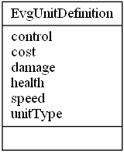

Figure 22: Pyreverse EvgUnitDefinition output

#### EvgUnit in definition.py

The class of the Everglades drone unit. Currently, a group must be all the same unit types. Thus, a group of eight units is treated as one unit with eight health values. Its only method is the unit initializer. Figure X shows the *pyreverse* class diagram.

Code Base Characterization

Properties:

1. *string* **unitType**: The type of the unit for the group.
2. *int* **count**: The amount of this type of unit for the group.
3. *ndarray<int>* **unitHealth**: An array of health values for each unit. Its length is the value of count.
4. *EvgUnitDefinition* **definition**: It contains the definition of the unit type.

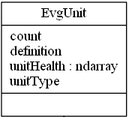

Figure 23: Pyreverse EvgUnit output

#### EvergladesGame in server.py

The class of the Everglades game. It contains the game logic. Figure X shows the *pyreverse* class diagram.

Properties:

1. *bool* **debug**: This flag allows the masking of fog of war for debugging purposes.
2. *dict* **player_names**: This contains the names of the agent modules.
3. *string* **output_dir**: The destination directory for telemetry output.
4. *Dict* **map_dat**: This contains the map data read from the configuration file.
5. *EvgMap* **evgMap**: This is an instance of the Everglades map.
6. *dict* **team_starts**: Contains team’s starting nodes, pulled from map_dat, which got it from the map json file. 0 = player 1 start, 1 = player 2 start, -1 = neutral nodes.
7. *ndarray<int>* **map_key1**: Length is the number of map nodes. Array sorted by index of evgMap node and populated by node IDs.
8. *ndarray<int>* **map_key2**: Length is the number of map nodes. Array sorted by node ID and populated by indices of evgMap nodes.
9. *list<int>* **p1_node_map**: Array of node IDs from player 1 perspective
10. *vectorize* **_vec_convert_node**: Vectorized version of _convert_node function.
11. *int* **fort_bonus**: Fortress defense multiplier.
12. *int* **watch_bonus**: Watchtower vision bonus.
13. *dict* **unit_dat**: Read Unit data from .json file. Contains the types and stats of the units (health, damage, speed, etc.).

Code Base Characterization

1. *list<EvgUnitDefinition>* **unit_types**: List of each type of unit with respective stats as retrieved from the .json file.
2. *dict* **unit_ids**: Key is int uid, the order that the types were processed, starting at 0. Value is unit_type.
3. *dict* **unit_names**: Key is unit_type. Value is int uid, the order that the types were processed, starting at 0.
4. *int* **current_turn**: The current turn in the game.
5. *dict* **players**: The key is the player key (0 or 1). The value is an instance of EvgPlayer.
6. *dict* **output**: Key is name of telemetry file. Value is the data for that telemetry file. Also contains a header.
7. *int* **total_groups**: Total amount of groups in the game
8. *int* **total_units**: Total amount of units in the game
9. *list<int>* **focus**: List of group IDs on which to focus.
10. *string* **dat_dir**: Folder name containing that game instance’s telemetry files

Methods:

1. **__init__ ()**: Initializes instance of EvergladesGame class
2. **board_init()**: Initializes the game board
3. **_convert_node()**: Returns corresponding node from p1_node_map
4. **unitTypes_init()**: Initializes the types of units
5. **game_init()**: Initializes the game by assigning player numbers and calling functions to initialize players and units.
6. **game_turn()**: Validates player turns and calls functions defining actions that make up a turn including movement, combat, capture, and building knowledge output.
7. **game_end()**: Calculates score based on controlled nodes and checks for game ending conditions. Outputs game data to telemetry files.
8. **debug_state()**: Outputs turn-by-turn debug information to console.
9. **board_state()**: Returns the state of the game board.
10. **player_state()**: Returns the state of the player’s groups.
11. **combat()**: Controls unit combat which occurs before movement. Damage is calculated, destroyed units and groups are removed, and output is sent to telemetry file.
12. **movement()**: Moves units to nodes. Outputs movement to telemetry file.
13. **capture()**: Checks for capture conditions and then captures nodes. Outputs node control data to telemetry file.
14. **output_init()**: Initializes the telemetry files.
15. **build_knowledge_output()**: Builds player knowledge of groups and nodes. Outputs data to telemetry file.
16. **write_output()**: Writes the telemetry files.

Code Base Characterization

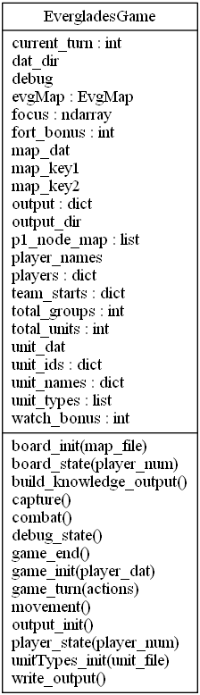

Figure 24: Pyreverse EvergladesGame output

#### EvergladesEnv in everglades_env.py

The class for the Everglades environment. It contains the OpenAI Gym for the project. Figure X shows the *pyreverse* class diagram.

Properties:

1. *int* **num_turns**: The number of turns in a game.
2. *int* **num_units**: The total number of units per player.
3. *int* **num_groups**: The number of groups per player.
4. *int* **num_nodes**: The number of nodes in the map.
5. *int* **num_actions_per_turn**: The number of actions a player may take per turn.

Code Base Characterization

1. *list<string>* **unit_classes**: The types of units in the game.
2. *Tuple* **action_space**: This defines the range of actions an agent may take.
3. *Box* **observation_space**: This defines the boundaries of observation.
4. *dict* **players**: The keys are 0 and 1 and the values are an instance of the agent class for the respective player.
5. *bool* **debug**: This flag allows the masking of fog of war for debugging purposes.
6. *list<dict_keys>* **pks**: The list of keys for the player dictionary.
7. *list<dict_keys>* **sorted_pks**: The sorted list of keys for the player dictionary.
8. *dict* **player_dat**: This contains the unit groups for each player.
9. *EvergladesGame* **game**: This is an instance of the Everglades game.

Methods:

1. **__init__()**: This initializes the instance of the EvergladesEnv class.
2. **step()**: This returns an observation, reward, done, and info for each timestep. It is returned from the environment every time an agent makes an action.
3. **reset()**: Resets the game.
4. **render()**: ***This function is empty.***
5. **close()**: ***This function is empty.***
6. **_build_observation_space()**: This is called when the Everglades environment is initialized. It sets the boundaries, creates, and returns the observation space.
7. **_build_groups()**: This builds the groups for the agent. It currently builds groups that are all the same type of unit.
8. **_build_observations()**: This returns the board state and player state per player.

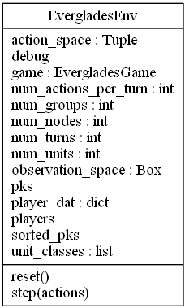

Figure 25: Pyreverse EvergladesEnv output

Code Base Characterization

The codebase characteriza

Game Telemetry Data

After an Everglades’ session is finished running, telemetry data is created a stored in a predetermined directory. Currently, the place it is being stored is the “game_telemetry” folder. Everglades generates several subfolders that houses different telemetry types. The figure below shows the contents of the “game_telemetry” directory. Inside each of these folders is a CSV file containing the appropriate telemetry.

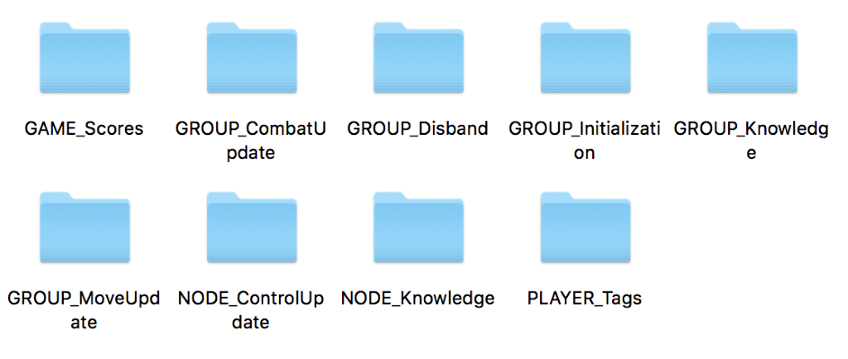

Figure 26: Telemetry Data directory hierarchy

Explanation of Telemetry

**GAME_Scores**

This telemetry file contains information on the scores of each player for each turn in the game.

* Turn Number - The current turn number
* Player 1 Score – The first players score during a specific turn
* Player 2 Score – The second player’s score during a specific turn
* Status – A flag that states if a game is completed or not (0 if in progress and 1 if finished)
* Focus – The unit that the camera will be located at for playback

Code Base Characterization

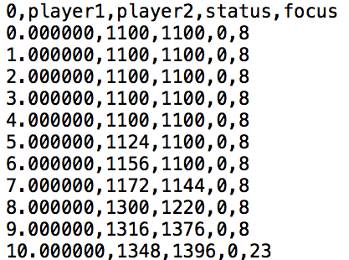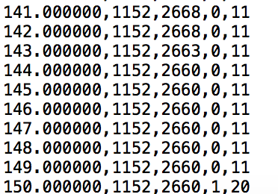

Figure 27: Game Score Telemetry Data

**GROUP_CombatUpdate**

This telemetry file contains information about combat between drone units after every turn.

* Turn Number – The turn number that the event took place
* Player – The player performing the combat action (Either a 0 or 1)
* Node – The number of the Node that a battle took place
* Groups - An array of Unit Group ID’s that took place in the combat sequence
* Unit – An array of ID’s belonging to units that participated in the combat sequence
* Health – The remaining health of Units that participated in combat sequence

**GROUP_Disband**

* This telemetry keeps track of whenever groups are removed from play due to combat.
* Turn Number – The turn number of when an event takes place
* Player – The player whose group was disbanded (Either a 0 or a 1)
* Group – The ID of the group that was disbanded

**GROUP_Initialization**

* Generated at the beginning of a match. In a match Turn 0 is each player’s turn to setup.
* Turn Number – Since initialization only occurs on Turn 0, this value is always 0
* Player – The player being initialized (Either a 0 or a 1)
* Group – The Group ID being defined
* Node – The Node that a group is being spawned on
* Types – An array of types
* Start – The starting Unit ID
* Count – The amount of each type to create

Code Base Characterization

**GROUP_Knowledge**

* Displays information of a player’s knowledge of nodes
* Turn Number - Current turn being examined
* Player - Current player being examined (Either a 0 or a 1)
* UnitTypes - List of unit types in a particular group
* UnitCount -Number of units in a group
* Status - Status of whether a group is at a node or in transit to a node (0 or 1 respectively)
* Node1 – If a group is not in transit to a node, this value is simply the value of the node a group is currently at. If the group is in transit, then this is the node that the group departed from.
* Node2 – If the group is in transit, this is the destination node of a travelling group. Otherwise, this value is unused.

**GROUP_MoveUpdate**

Telemetry data containing information about when groups are moving from one node to another

* Turn Number – The turn number that moving took place
* Player – The player whose group is moving
* Group – The ID of the group that’s moving
* Start – The Node ID where the move originated
* Destination – The ID of the node that a group is moving towards
* Status - RDY_TO_MOVE indicates moving to the edge, IN_TRANSIT is during spline transition between nodes, ARRIVED when spline transition is complete

**NODE_ControlUpdate**

Telemetry data that contains information pertaining to when a node’s control status changes

* Turn Number – The number of the turn that the change took place
* Node – The number of the node whose status was updated
* Faction – The ID of the player who achieved control of the node
* Control Value – The current control value of the node
* Controlled – A boolean value that states whether a node has been claimed

Code Base Characterization

**NODE_Knowledge**

Telemetry data that displays information on the amount of knowledge that a player possesses

* Turn Number – The turn that is being documented
* Player – The ID of player
* Nodes – A list of Node IDs
* Knowledge – List of node knowledge (0 = none, 1 = partial, 2 = full)
* Controller – List of IDs representing who controls a node (-1 if it’s neutral)
* Percent – List of percentages of control for each controller

**PLAYER_Tags**

Documents basic information about the AI that was used in the game

* Turn Number – The last turn of the match
* Player 1 – The file name used for the first player
* Player 2 – The file name used for the second player

Procedurally Generated Game Board

Implementation Ideas

Map Generation Using Breadth First Search:

Breadth-first search (BFS) is an algorithm for traversing or searching tree or graph data structures. It starts at the tree root and explores all the neighbor nodes at the present depth prior to moving on to the nodes at the next depth level. This algorithm could be used as the basis for a procedurally generated game board.



Figure 28: Breadth First Search Example

Procedurally Generated Game Board

The game currently contains a single game board as show in the image below. The base layout of this board is simply a 3x3 grid of nodes with 8 possible directions of connecting (N, NE, E, SE, S, SW, W, NW).



Figure 29: Default Game Board

Procedurally Generated Game Board

Chosen Method Overview

The method chosen for our implementation was the Breadth First Search approach. This method allowed a quick and efficient method of generating a game board with ensured connections and variability.

Process:

The main components used for this method are a 2-dimensional integer array, and a Queue of points. The 2-dimensional integer array will be in the size range of 3x3 to 7x7 to keep the total node count under 50. All values of this array are initialized to 0.

|  |  |  |  |  |  |  |
| --- | --- | --- | --- | --- | --- | --- |
| 0 | 0 | 0 | 0 | 0 | 0 | 0 |
| 0 | 0 | 0 | 0 | 0 | 0 | 0 |
| 0 | 0 | 0 | 0 | 0 | 0 | 0 |
| 0 | 0 | 0 | 0 | 0 | 0 | 0 |
| 0 | 0 | 0 | 0 | 0 | 0 | 0 |
| 0 | 0 | 0 | 0 | 0 | 0 | 0 |
| 0 | 0 | 0 | 0 | 0 | 0 | 0 |

Table 4: Initial Game Board 2d Array

To begin the process, an initial point (0, 3) needs to be added to the Queue. This value in the 2d array will be set to 1 then the while loop will begin. This loop will run until the Queue is empty.

|  |  |  |  |  |  |  |
| --- | --- | --- | --- | --- | --- | --- |
| 0 | 0 | 0 | 0 | 0 | 0 | 0 |
| 0 | 0 | 0 | 0 | 0 | 0 | 0 |
| 0 | 0 | 0 | 0 | 0 | 0 | 0 |
| 1 | 0 | 0 | 0 | 0 | 0 | 0 |
| 0 | 0 | 0 | 0 | 0 | 0 | 0 |
| 0 | 0 | 0 | 0 | 0 | 0 | 0 |
| 0 | 0 | 0 | 0 | 0 | 0 | 0 |

Table 5: Initial Node Added

For each iteration of the while loop, the first point in the list is removed from the queue to be used for the current operations. Using this point, all 8 possible connections to this point are

checked for the possibility of creating a new node in the map. For each point that is pulled from the queue, an initial weight will be created depending on the number of possible connections and the overall base weight factor. For example, the initial point (0, 3) has a possible 5 connections,

so using a base weight factor of 1, its initial weight would be 1/5 or 0.2. Possible connections are checked in a clockwise direction, but the starting point will be random for each center point. Let’s say the random direction chosen for the initial point (0, 3) is East, or (X + 1, Y + 0). After this location (1, 3) is ensure valid, a random value from 0 to 1 will be generated. If the value is less than or equal to the weight, a node will be created there. When a node is created, that location in the 2d array will be set to 1, the weight will be decreased by a factor of 0.5/Number of Connections, and the new point will be added to the queue. If a node is not created, that location in the 2d array will be set to -1 and the weight will be increased by a factor of 1/Number of Connections. Increasing the weight by this factor on each failed creation will ensure that by the last location check, a connecting node will be created.

Procedurally Generated Game Board

For this example, let’s say the random value from 0 to 1 for the East check is 0.35. This value is greater than the weight of 0.2 so the node creation failed. The location (1, 3) in the 2d array now has a value of -1 and the weight is increased to 2/5 or 0.4.

|  |  |  |  |  |  |  |
| --- | --- | --- | --- | --- | --- | --- |
| 0 | 0 | 0 | 0 | 0 | 0 | 0 |
| 0 | 0 | 0 | 0 | 0 | 0 | 0 |
| 0 | 0 | 0 | 0 | 0 | 0 | 0 |
| 1 | -1 | 0 | 0 | 0 | 0 | 0 |
| 0 | 0 | 0 | 0 | 0 | 0 | 0 |
| 0 | 0 | 0 | 0 | 0 | 0 | 0 |
| 0 | 0 | 0 | 0 | 0 | 0 | 0 |

Table 6: First Possible Connection Checked

Procedurally Generated Game Board



|  |  |  |  |  |  |  |
| --- | --- | --- | --- | --- | --- | --- |
| 0 | 0 | 0 | 0 | 0 | 0 | 0 |
| 0 | 0 | 0 | 0 | 0 | 0 | 0 |
| 1 | -1 | 0 | 0 | 0 | 0 | 0 |
| 1 | -1 | 0 | 0 | 0 | 0 | 0 |
| -1 | 1 | 0 | 0 | 0 | 0 | 0 |
| 0 | 0 | 0 | 0 | 0 | 0 | 0 |
| 0 | 0 | 0 | 0 | 0 | 0 | 0 |

Table 7: All Connections Checked for Initial Node

After this step, at least one connecting node will always be generated. This is ensured by the weight factor being set to at least the initial value of 1 divided by the number of possible connections. Initially setting this value to be larger will increase the average number of nodes generated for each initial node, thus resulting in a denser map.

Procedurally Generated Game Board

At this point, 2 new points have been added to the queue, so the process continues. The next point to be pulled will be the first connecting node added to the queue which in this case would be (1, 2). This point has a possible 5 new connections as well so the initial weight will be set to 0.2. These connections will be run through and the new points will be added to the queue.

|  |  |  |  |  |  |  |
| --- | --- | --- | --- | --- | --- | --- |
| 0 | 0 | 0 | 0 | 0 | 0 | 0 |
| 0 | 0 | 0 | 0 | 0 | 0 | 0 |
| 1 | -1 | 0 | 0 | 0 | 0 | 0 |
| 1 | -1 | -1 | 0 | 0 | 0 | 0 |
| -1 | 1 | 1 | 0 | 0 | 0 | 0 |
| 1 | -1 | 1 | 0 | 0 | 0 | 0 |
| 0 | 0 | 0 | 0 | 0 | 0 | 0 |

Table 8: All Connections Checked for 2nd Node



Procedurally Generated Game Board

The next point to be pulled from the queue will then be the second point added from the initial point’s connections (0, 4). This point has a possible 2 connections so the initial weight will be set to 1/2 or 0.5.

|  |  |  |  |  |  |  |
| --- | --- | --- | --- | --- | --- | --- |
| 0 | 0 | 0 | 0 | 0 | 0 | 0 |
| -1 | 1 | 0 | 0 | 0 | 0 | 0 |
| 1 | -1 | 0 | 0 | 0 | 0 | 0 |
| 1 | -1 | -1 | 0 | 0 | 0 | 0 |
| -1 | 1 | 1 | 0 | 0 | 0 | 0 |
| 1 | -1 | 1 | 0 | 0 | 0 | 0 |
| 0 | 0 | 0 | 0 | 0 | 0 | 0 |

Table 9: All Connections Checked for 3rd Node



Procedurally Generated Game Board

|  |  |  |  |  |  |  |
| --- | --- | --- | --- | --- | --- | --- |
| 1 | -1 | 1 | 0 | 0 | 0 | 0 |
| -1 | 1 | 1 | 0 | 0 | 0 | 0 |
| 1 | -1 | -1 | 0 | 0 | 0 | 0 |
| 1 | -1 | -1 | 0 | 0 | 0 | 0 |
| -1 | 1 | 1 | 0 | 0 | 0 | 0 |
| 1 | -1 | 1 | 0 | 0 | 0 | 0 |
| -1 | 1 | -1 | 0 | 0 | 0 | 0 |

Table 10: All Nodes Generated for Left Side of Map

Procedurally Generated Game Board

|  |  |  |  |  |  |  |
| --- | --- | --- | --- | --- | --- | --- |
| 1 | -1 | 1 | 0 | 1 | -1 | 1 |
| -1 | 1 | 1 | 0 | 1 | 1 | -1 |
| 1 | -1 | -1 | 0 | -1 | -1 | 1 |
| 1 | -1 | -1 | 0 | -1 | -1 | 1 |
| -1 | 1 | 1 | 0 | 1 | 1 | -1 |
| 1 | -1 | 1 | 0 | 1 | -1 | 1 |
| -1 | 1 | -1 | 0 | -1 | 1 | -1 |

Table 11: Generated Map Mirrored to Right Side

This step ensures that the randomly generated game board will always be fair for each player. An asymmetrical game board could allow one player to have more nodes that can be reached easily than the other player, which would result in the player earning more points.

Procedurally Generated Game Board

The center line is filled in a similar way but by checking for existing connections to the point, and an overall weight for the center line. The points are processed from top to bottom, but the starting point is chosen at random. The initial weight will be set to a value around 2/8 or 0.25 to 4/8 or 0.5, varying my multiples of 1/8. Let’s say the initial weight is set to 0.375 and the initial point is (3, 2). This point has 4 connecting points so a point could be placed here. If the random value from 0 to 1 is 0.23, the creation succeeds. The point in the 2d array is set to -1 and the weight is decreased to 0.3125.

|  |  |  |  |  |  |  |
| --- | --- | --- | --- | --- | --- | --- |
| 1 | -1 | 1 | 0 | 1 | -1 | 1 |
| -1 | 1 | 1 | 0 | 1 | 1 | -1 |
| 1 | -1 | -1 | 0 | -1 | -1 | 1 |
| 1 | -1 | -1 | 0 | -1 | -1 | 1 |
| -1 | 1 | 1 | 1 | 1 | 1 | -1 |
| 1 | -1 | 1 | 0 | 1 | -1 | 1 |
| -1 | 1 | -1 | 0 | -1 | 1 | -1 |

Table 12: First Center Connecting Node Added



Procedurally Generated Game Board

This process will proceed until all center points have been processed. A successful map creation will be determined by the number of center connecting nodes.

|  |  |  |  |  |  |  |
| --- | --- | --- | --- | --- | --- | --- |
| 1 | -1 | 1 | 1 | 1 | -1 | 1 |
| -1 | 1 | 1 | -1 | 1 | 1 | -1 |
| 1 | -1 | -1 | -1 | -1 | -1 | 1 |
| 1 | -1 | -1 | -1 | -1 | -1 | 1 |
| -1 | 1 | 1 | 1 | 1 | 1 | -1 |
| 1 | -1 | 1 | 1 | 1 | -1 | 1 |
| -1 | 1 | -1 | -1 | -1 | 1 | -1 |

Table 13: All Center Connecting Nodes Added

This process will almost always create a valid map on the first try but a safeguard will be used to recreate the map if the number of center connecting nodes is less than a set value from 1 to 4.

Procedurally Generated Game Board

During the research phase of the project, a small Winforms application was created to help demonstrate the game board creation algorithm. Here are some examples of 7x7 game boards with an initial weight factor of 2.0.



Figure 30: Sample Map 1 – Weight Factor 2.0

Figure 31: Sample Map 2 – Weight Factor 2.0



Figure 33: Sample Map 4 – Weight Factor 2.0

Figure 32: Sample Map 3 – Weight Factor 2.0

Procedurally Generated Game Board

Changing the weight factor will affect the density of nodes. Here are some examples with a weight factor of 1.0.



Figure 35: Sample Map 6 – Weight Factor 1.0

Figure 34: Sample Map 5 – Weight Factor 1.0

And some examples with a weight factor of 3.0.



Figure 37: Sample Map 8 – Weight Factor 3.0

Figure 36: Sample Map 7 – Weight Factor 3.0

Procedurally Generated Game Board

Just to demonstrate the versitality of this process, here is an example of a 35x35 board, which would be much too large for the game.



Figure 38: Sample Map 9 – Weight Factor 1.0 – 35x35 Game Board

Using this method for the creation of the base board allows for creation of game boards with multiple factors of variability such as changing the density of nodes and the factors required for a successful board.

Procedurally Generated Game Board

Another factor to be determined during this process is whether or not the node is a Fortress, Watchtower, or Neither. This will be determined by comparing a random value from 0 to 1, to set weight boundaries. For example, the Fortress weight can be set to 0.2 and the Watchtower weight can be set to 0.8. If the random value is less than or equal to 0.2, the node is a Fortress, if the value is greater than or equal to 0.8, the node is a Watchtower, and if the node is between 0.2 and 0.8, the node is just a normal node. This gives a 20% chance each for Fortesses and Watchtowers and a 60% chance for the node to be neither. These intial weight boundaries can be changed to determine the frequency of Fortresses and Watchtowers depending on what is desired. This would be stored in the process above by setting the value in the 2d array for Fortresses to 2 and Watchtowers to 3.

|  |  |  |  |  |  |  |
| --- | --- | --- | --- | --- | --- | --- |
| 2 | -1 | 1 | 1 | 1 | -1 | 2 |
| -1 | 1 | 3 | -1 | 3 | 1 | -1 |
| 1 | -1 | -1 | -1 | -1 | -1 | 1 |
| 1 | -1 | -1 | -1 | -1 | -1 | 1 |
| -1 | 1 | 2 | 1 | 2 | 1 | -1 |
| 1 | -1 | 1 | 3 | 1 | -1 | 1 |
| -1 | 3 | -1 | -1 | -1 | 3 | -1 |

Table 14: Generated Board with Fortresses and Watchtowers

After the 2 dimensional array has been generated for the game board, it will need to be converted so that the game server can read in the data for each node. The default map is currently being stored and input as a .json file. This .json file stores the nodes in an array called “nodes”. This array contains each node and it’s ID, Radius, Control Points, Structure Defense, Resources, Array of Connections to other nodes, and an int called TeamStart that marks which nodes are the starting points for each team.

Procedurally Generated Game Board



Figure 39: Basic Node Example

To match this format, the generated 2 dimensional array will need to run through a processing double for loop. This loop will need to assign ID numbers to each possible location for a node with the top left node being 1 and the bottom right being 49. There will not actually be 49 nodes in every map but to maintain the randomly generated layout it will need to keep track of which possible node locations have a node. The distance values between these nodes will start at a standard value with slight variations so that it is not one distance for all connections. The radius will be a standard set value that is dependant on the max number of nodes for the generated map. For example, due to the limited map size in the post processing, a 7x7 map will need to have smaller nodes than a 5x5 map. The ControlPoints value, or Points for Controling the node, will like be a random value in a range set by the actual location of the node. Nodes near the center of the map will be worth more points than nodes out on the sides. The Resource array holds the

Procedurally Generated Game Board

type of node if it is a special node location. The only options for this will be “DEFENSE” for a Fortress and “OBSERVE” for a Watchtower.

The list of connections will need to retrieved when looping through the 2 dimensional array. Once the array finds a location with a node it will need to then check the 8 surrounding possible connections to see which others are also nodes. The ID values for connecting nodes can be calculated by using this equation:

$$\left((curY-1)*maxX\right)+curX$$

For example, the 3rd node on the 5th line would be:

$$\left((5-1)*7\right)+3=31$$

Once all the connections to the node are found, they will be added to an array to then be converted into .json. The .json file can be dynamically generated in Python using the **json** class.

The process for generated a new random map on each game will involve executing a python script that creates the file RandomMap.json in the data folder. This Python script will be executed at the beginning of the game code execution, directly before the default map is currently being loaded in.



Figure 40: Fortess Node Example

Procedurally Generated Game Board

Unreal Engine Rendering

The final step for completing the Procedurally Generated Game Board is rendering the board in the Unreal game client. The default game board is rendered using a hardcoded game level with all the nodes already in their correct location. This level is loaded immediately on startup but covered by the main menu which is also loaded at this time. This level and loading order could not be easily altered to accommodate the random game board so a new process had to be created.

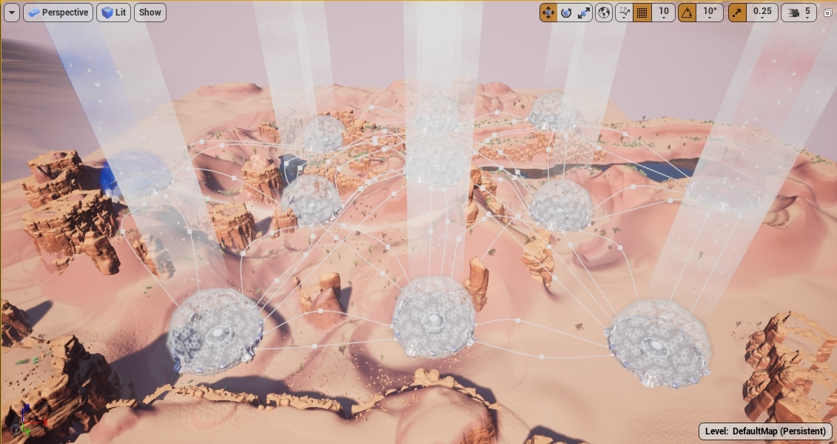

Figure 41: Default Map Editor View

Due to the layout of the terrain for the default level, the nodes of the random game boards could not be dynamically generated as the nodes would not generate in the proper positions of the terrain. To overcome this, a new level was created will all possible nodes pre-placed in the correct position. These node objects were assigned an ID corresponding to the ID of that same location in the Python map generation. The size of the node object was reduced so that up to 49 nodes could fit in the terrain.

Procedurally Generated Game Board

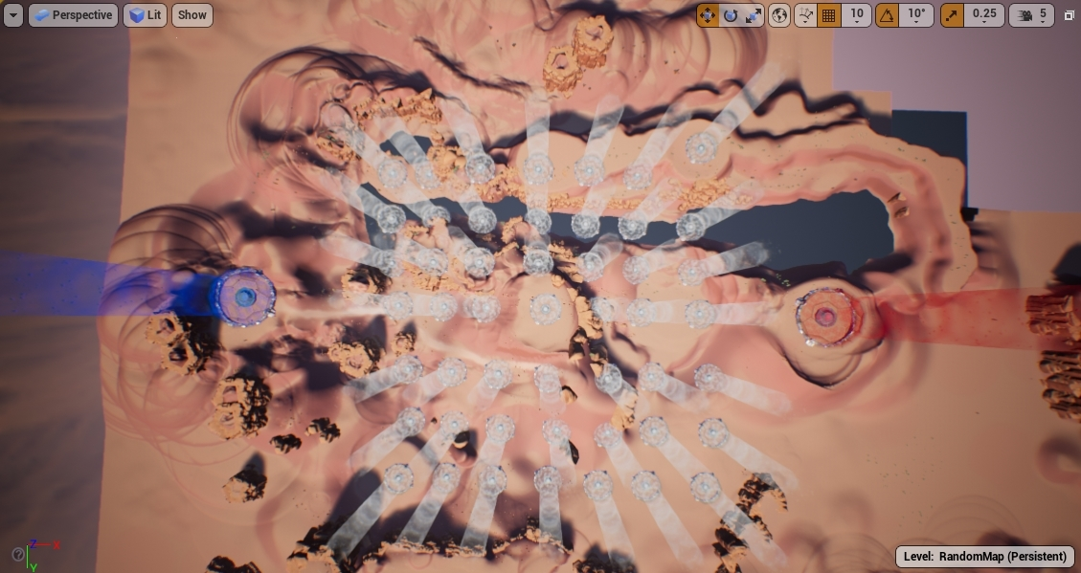

Figure 42: Random Map Editor View

To properly load the correct level, a new process had to be created for the startup of the game. The main menu for this game is set to show on any level load, which was fine when there was only one level that would ever be loaded. If a match run with a random game board is selected, loading the random level would trigger the main menu to be displayed again. To prevent this from happening, a new global variable was added to store the folder name for the selected telemetry data. This global variable is set after a telemetry folder is selected from the menu. On all level loads, this variable is checked to see if it already has a value. If it does, that means a telemetry folder has already been selected but a different level had to be loaded. The main menu is then not shown, and the game will go ahead to simulate the selected folder. After the completion of a match simulation, clicking the Return to Main Menu button will clear out this global variable so that another match can be shown.

Now that the game board can change with each match, new telemetry data is needed for the Unreal game client to know the layout of the board. A new telemetry folder was added to the main match data folder that stores the IDs of the nodes used in that match’s board. After a folder is selected from the main menu in the game client, the game will first loop through each node of the loaded level. Each node ID will be compared to the list of nodes in the telemetry data to check if that node was included in the random board. If a node was not included, it will be hidden on the level.

Procedurally Generated Game Board

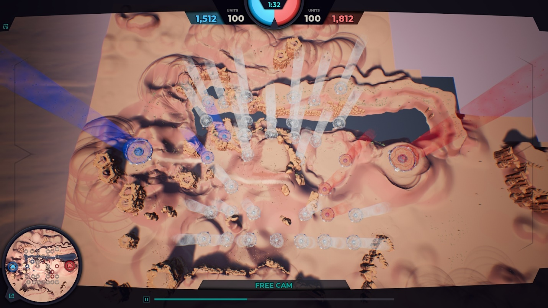

Figure 43: Random Map In-Game

In addition to the default game board being hardcoded, the map and mini map were also hardcoded for the default layout. Each node in the map and mini map was manually placed and linked to the corresponding node. To create a map and mini map for any random game board, new user interface objects for each had to be created. For both, every possible node had to be placed and linked to the corresponding node in the main level.

Procedurally Generated Game Board

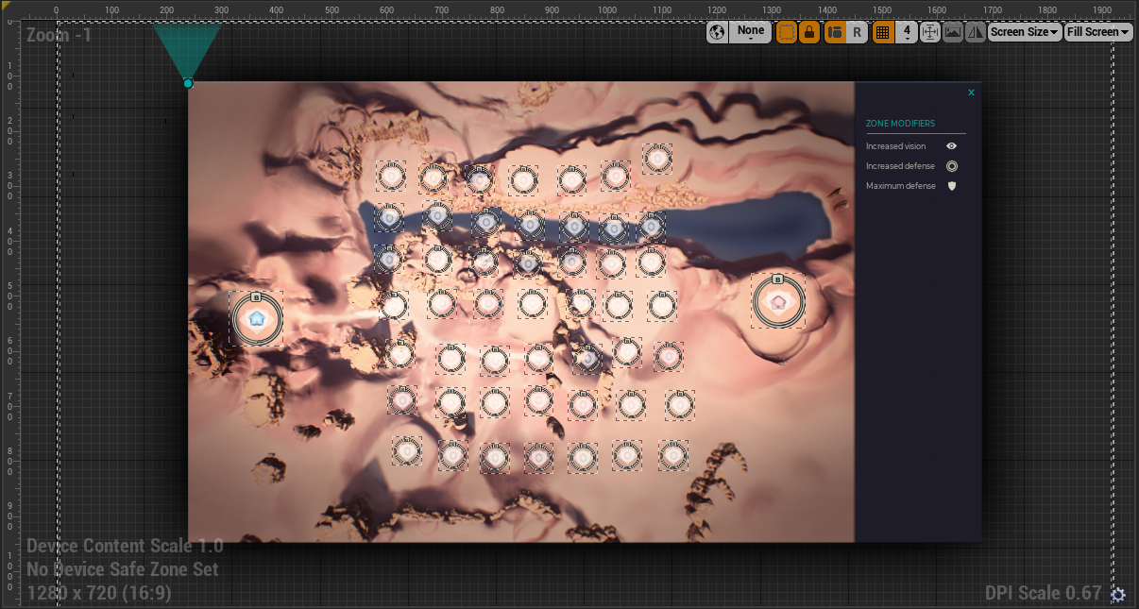

Figure 44: UI Map Design for Random Board

The mini map is a part of the overall heads up display for the spectator so a second version of that had to be created to accommodate the random game board.

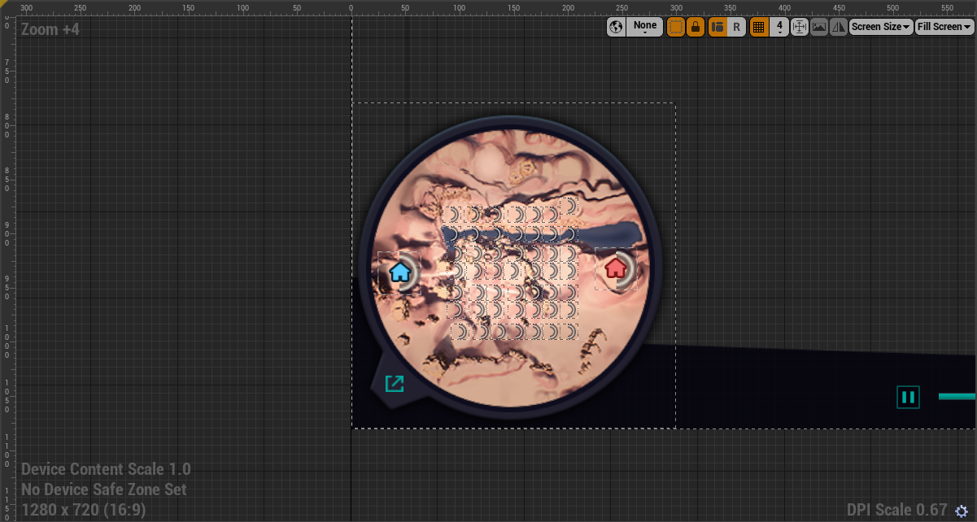

Figure 45: UI Mini Map Design for Random Board

Procedurally Generated Game Board

To properly display only the nodes included in the random game board for that match, a similar process to the node hiding for the main level is done. The game will loop through each node object on the two maps and compare the corresponding ID to the selected telemetry data.

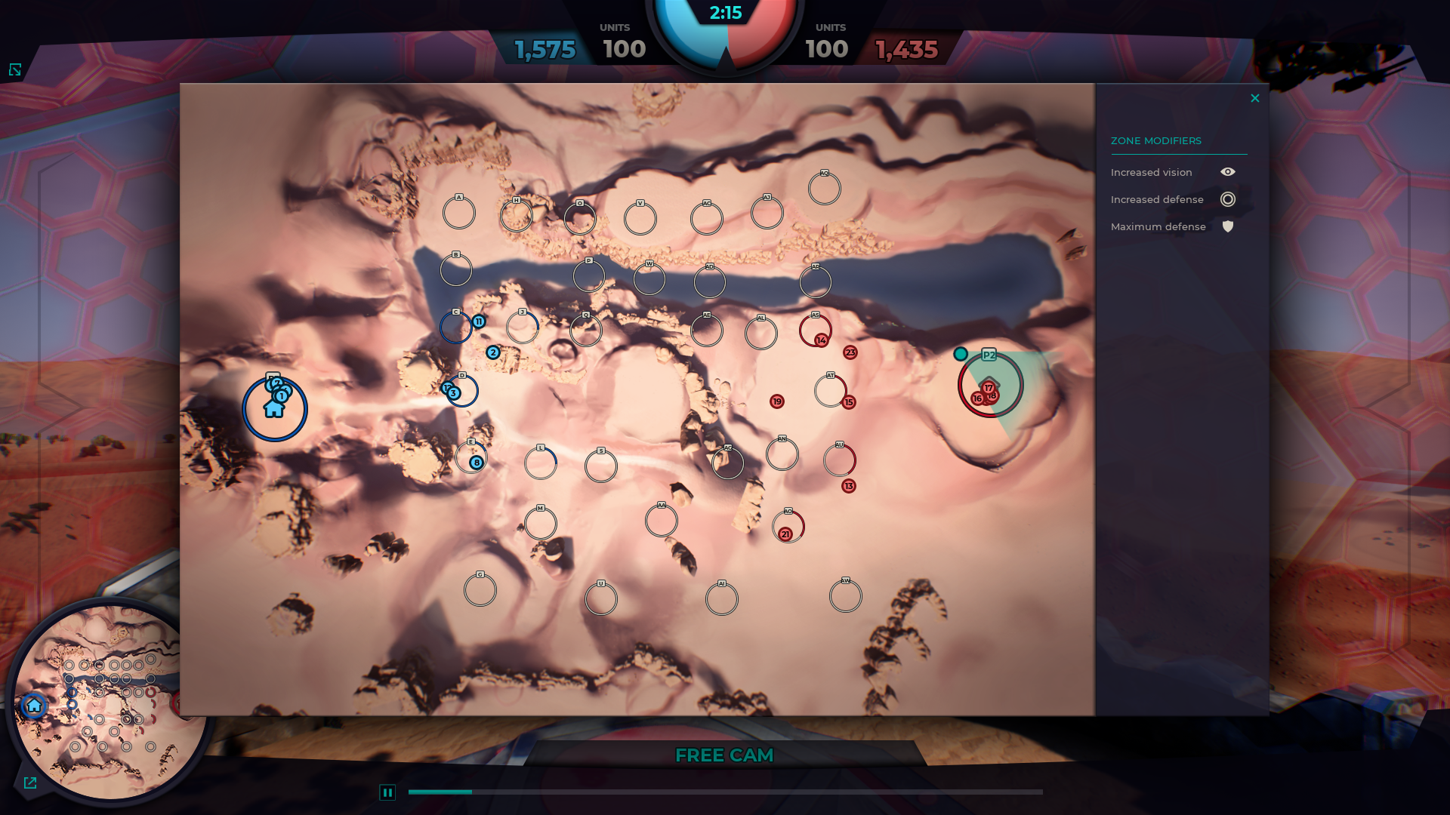

Figure 46: UI Map for Random Board

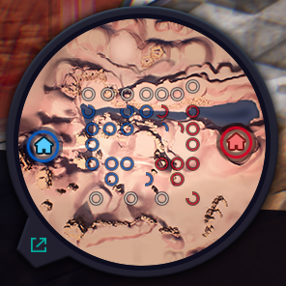

Figure 47: UI Mini Map for Random Board

Wind Effects with Seeded Stochasticity

Wind Physics Overview

Wind in a 2-D space can be represented by the Force vector,

**F = <x,y>**

where x is the Force in the x-direction and y is the force in the y-direction. The direction of any two nodes can also be represented by vector, in this case it is the unit vector,

**U = <a, b>**

The representation between these two vectors can be shown in the diagram below,

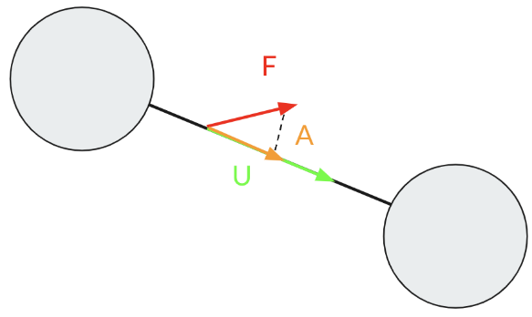

Figure 48: Representation of wind force vector on a connection

In a system with one dimensional movement, only the force one the direction of the connection needs to be accounted for. Therefore, the wind value between any two nodes can be represented

Wind Effects with Seeded Stochasticity

as the scalar projection between them. For any orientation of F and U, the scalar projection, or the magnitude of A, can be found using the following formula where V is a unit vector,

Scalar = F•V

Wind affects the game board through a scalar multiplier that will potentially slow or increase the movement capabilities of a swarm depending on which way they are travelling. For example, if the wind is blowing in the direction that a unit is a traveling, then that unit will receive a movement speed increase when traveling across those vertices. The opposite holds true for a unit traveling in the opposite direction; they will receive a movement decrease. These modifiers are represented by a percentage that is derived from dividing the force by the maximum force that can be achieved by a wind vector. This percentage is then be applied to any units moving over that vector. For example, if a unit can move say 8 units in one turn and there is a -50% movement speed modifier when moving over a given vertex, then that unit will only be able to travel 4 units when going over that vertex.

Stochastic Seeding

Stochastically seeding in Python is done by changing executing the seed() function found in the random library. When the seed value is set, it ensures that the random numbers generated in a program are the same sequence of numbers. When the seed is not set, Python uses the time of the system to determine the seed, which means that the seed used by a program will be completely random. Another quick note about the seed value is that if the seed function is called again, that will become the new seed used for generation. If the same seed is used again, it will simply start number generation from the first number generated. Below is a short example how a seed functions in Python,

Wind Effects with Seeded Stochasticity

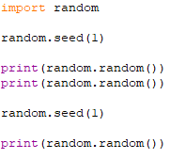

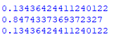

Figure 49: Simple randomization function and related output

As shown from the output, when *random()* is run using 1 as its input, it returns the first number again. The seed is used in the Everglades project to ensure that a repeated arrangement of wind can be generated for a given

Relevant Existing Code

In the current Everglades code, there is a placeholder value for stochasticity stored in the file “GameSetup.json”. While the value currently has no use in the Everglades game. It is perfect for storing the current seed to use for stochastic number generation. Storing the seed in a JSON is the best method of implementation, as it is easily accessible. The stochasticity value is read in during a game’s initialization and is used to generate the seed used for randomization.

Wind Effects with Seeded Stochasticity

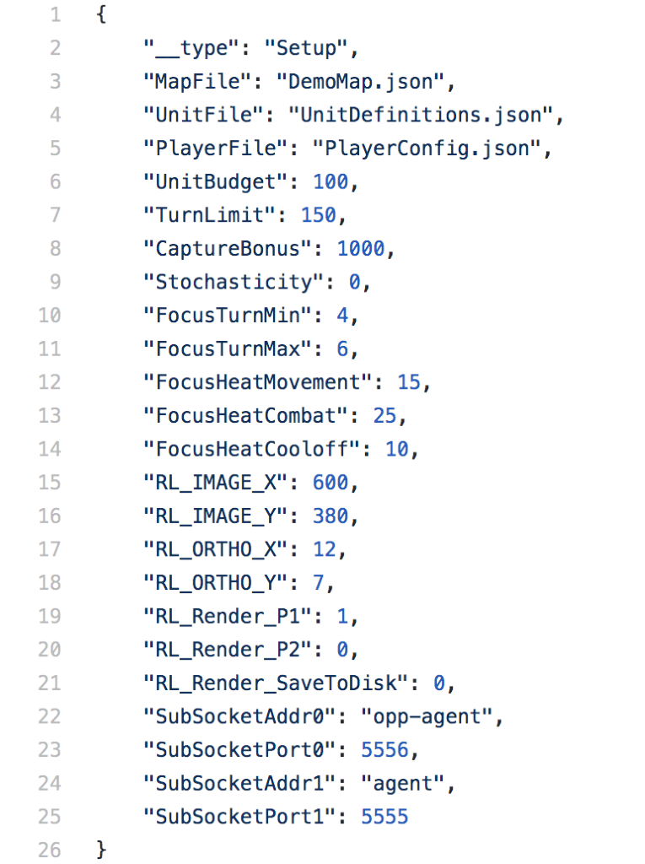

Figure 50: GameSetup initialization file

Recreating the Game Board

When the game board is passed to server, it needs to be recreated so that it can passed to the wind library. This needs to be done in order to determines the direction of every connection, which is important for calculating the wind modifier. The board is represented as a two-dimensional array where each position in the array corresponds to a possible node number. The possible numbers are incrementally generated going first top to bottom then left to right. Below is an example of all the possible node numbers for a 3x3 board,

Wind Effects with Seeded Stochasticity

|  |  |  |
| --- | --- | --- |
| 2 | 5 | 8 |
| 3 | 6 | 9 |
| 4 | 7 | 10 |

This is considered the “middle” of the game board. Nodes number 1 and 11 for a 3x3 board are reserved as the base nodes for each team. The position of a node in the 2D array can be calculated using the following formula,

**(row + 1) + (Ysize * (col – 1)) = (row, col)**

The left side of the equation denotes the number of the node and the right is the location of the node being looked at. An example is if you are looking at the first column and second row of the “middle” of a 3x3 board, then the equation would be (2 + 1) + (3 * 0) = (2, 1) -> 3 = (2,1). A dictionary is created where each key is the node number, and each value is its position. This dictionary is then used on every node number existing in the game to generate its representation. Spaces where a node isn’t present is filled with a -1 flag. The nodes are then numbered sequentially starting at 0 using the same numbering schema. Below is an example of a generated game board that will be passed to the wind library,

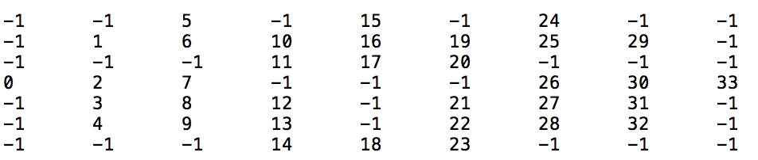

Figure 51: Image generated using completely random number generation

The wind program then finds every node (a space that isn’t a -1) and determines all of its neighboring nodes. Each node has eight possible neighbors.

Perlin Noise

The Everglades wind effect does not simply use a completely random number generation. Instead, it uses Perlin noise to generate the random numbers. Perlin noise is extremely effective

Wind Effects with Seeded Stochasticity

at creating numbers that are more natural and holistic. These kinds of numbers are beneficial in the application of wind because wind is a natural Phenomenon that abides by natural laws and moves holistically. Below are two images that use Perlin noise and completely random number generation to calculate the grayscale values for each pixel. The Perlin noise values are much more holistic than the completely random number generation which resembles static noise.

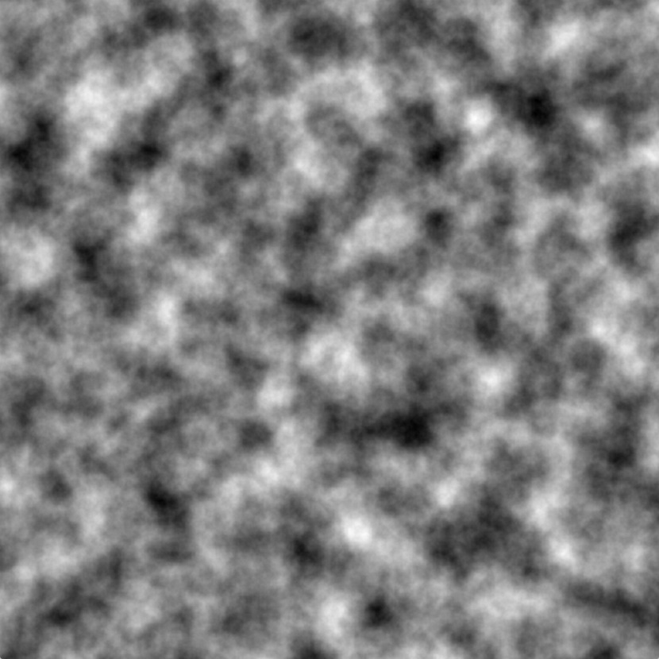

Figure 52: Image generated using Perlin noise [10]



Figure 53: Image generated using completely random number generation [10]

Wind Effects with Seeded Stochasticity

Vector Field

The wind is represented as a 2D field containing a collection of vectors, where each vector’s position indicates its associate node in the game board. The wind values are generated using Perlin noise numbers as the angle of the vector in radians and then generating the x and y-components of using the angle. The x-component is calculated using the cosine of the angle and the y-component is calculated using sine of the angle. Below is a diagram that shows how the vectors are generated,

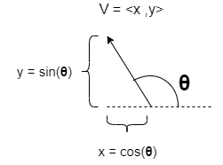

Figure 54: Representation of vector generation

Wind maps can also be mirrored to ensure that the playing field is fair for both agents participating in the game. In order to ensure complete fairness, the middle wind vectors are generated as a <0,0> vector to ensure that neither actor gets an unfair advantage. While a 2D vector field cannot be used to its full potential in a game with one dimensional movement, it is scalable. This means that, if the Everglades game ever decides to take advantage of two-dimensional movement, this representation of wind can easily be implemented with it. Below are two images of wind vector

Wind Effects with Seeded Stochasticity

maps, a non-mirrored and mirrored example. Stochasticity influences the vector field by altering the offset of where the Perlin noise values are generated. The offset is a random value generated between 0 and 10000, assuring a wide arrange of possible values.

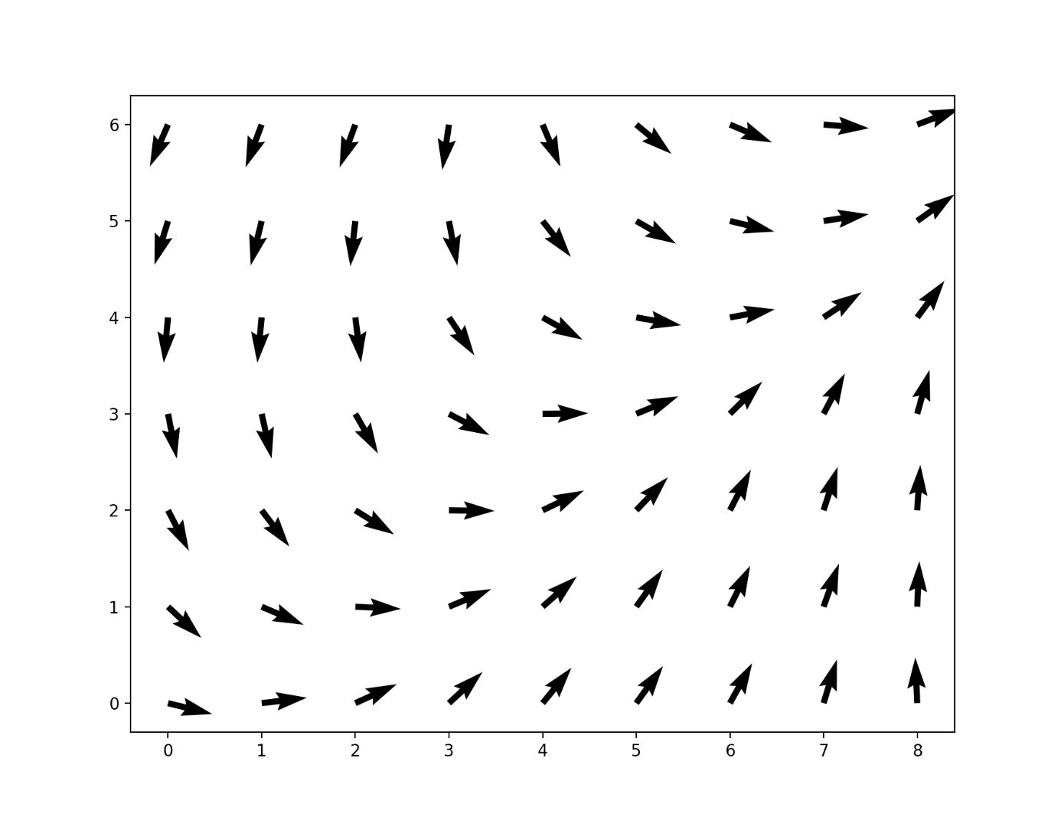

Figure 55: Wind vector field example

Wind Effects with Seeded Stochasticity

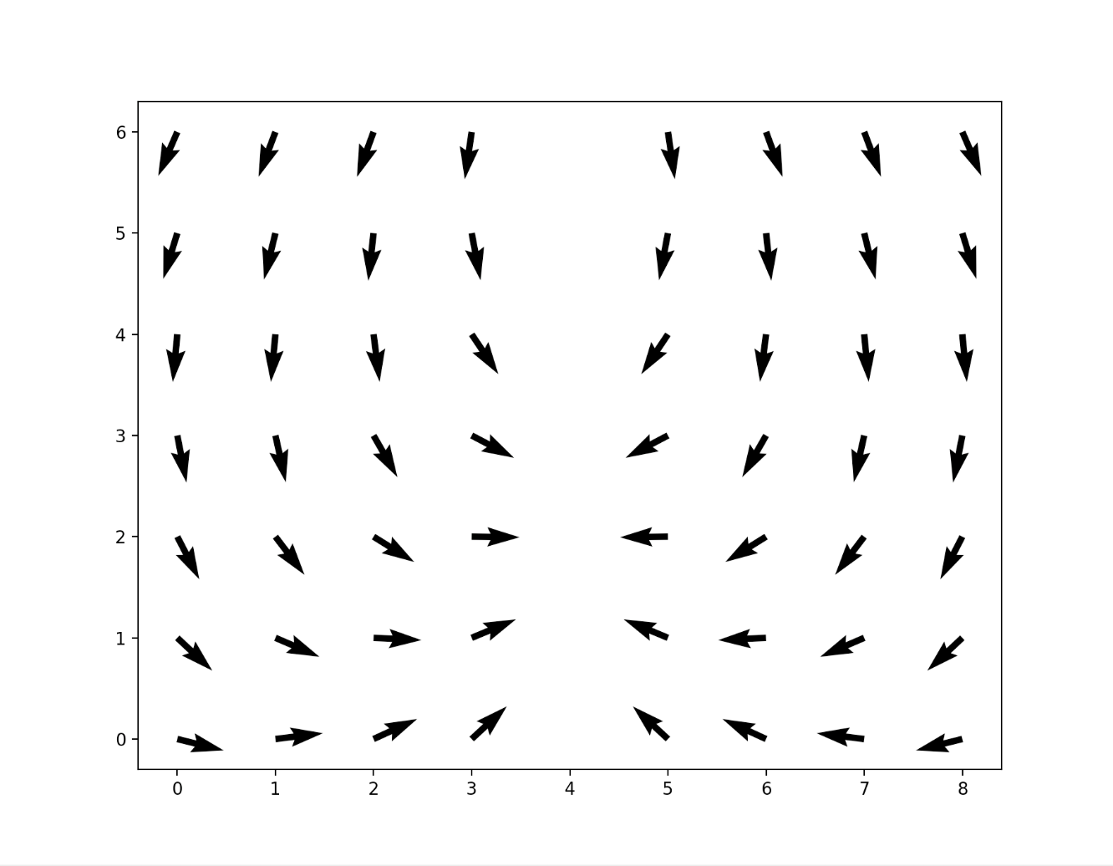

Figure 56: Mirrored vector field example

Movement logic for the Everglades project lies in the server.py file in the movement() function. This function executes the movement of every group of drones for each player in a session. It iterates through every group of drones belonging to a player, checks if that drone is not destroyed, and then declares that the group is moving. The code has been changed to affect a drone in the process of moving so that it is influenced by the scalar wind value. It should be noted that the function checks if a group has travelled half the distance to its destination. The reasoning behind this is that a group is experiencing the force of its destination node more than its departure node. This means that the scalar value calculated using the destination node instead.

Wind Effects with Seeded Stochasticity

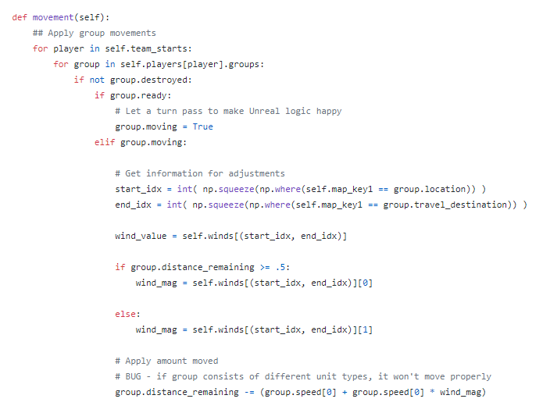

Figure 57: Movement function code snippet

High-Level Implementation

Below is a diagram displaying how the wind will be implemented on a game board. Each of the vertices in the game board has a corresponding wind value. As stated before, this is determined by generating the scalar projection of a wind vector onto the unit vector of a connection’s direction. In this example, only the scalar values for a node travelling from 1 outward are displayed.

Wind Effects with Seeded Stochasticity

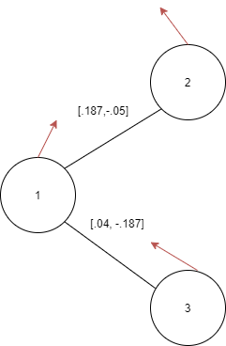

Figure 58: High level representation of wind vectors and scalars

Data Structure Implementation

The wind scalar values are stored in a HashMap, or dictionary, where the key value is a tuple value containing the node values of the departing and destination nodes for a group’s movement over a given connection. Every connection is accounted for twice in the HashMap, one in each direction that a node can possibly travel. The value for each key are the scalar multiplier values that will be applied to a group when it is travelling over that connection There are two values because the other connections wind vector is used to generate the scalar when a unit has travelled more than halfway between a connection. The maximum value for a scalar is 20%, meaning that the range of values that a node can be affected in their movement is a -20% to 20% difference from their original movement.

Wind Effects with Seeded Stochasticity

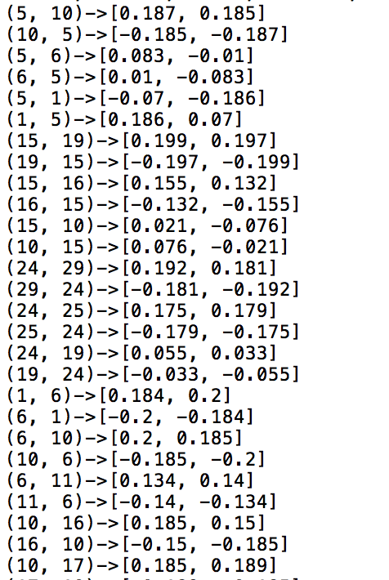

Figure 59: Wind scalar HashMap example

Wind Effects with Seeded Stochasticity

Entire Process of Wind Data Structure Generation

Below is a step by step walkthrough of the every step in the wind generation:

1. Game board is recreated and passed to the wind library
2. Wind library generated wind vector field that is the same size as the game board
3. Generated game board is parsed
   1. Connection direction is calculated
   2. Wind value associated with node position is obtained
   3. Scalar projection is calculated and added to the dictionary
   4. Connection heading in other direction is added as well
4. When group is moving, wind HashMap lookup is performed to find the appropriate scalar value

Unit with Sensor

Purpose

The purpose of creating a new unit with an attached sensor is to introduce new elements of strategy to the game. This may alter the way that AI agents play the game, provide new strategies, or create new challenges.

The sensor will be designed to participate in the current version of Everglades as well as having future functionality. This means that the unit will have unique bonuses to enhance the game for agents. However, it will also be able to collect data based on visual elements in Unreal. Since this visual data is post-processed, it will not affect current gameplay but may be used in future iterations.

Sensor Background Research

The sponsor gave the team three options for sensors to implement: infrared (IR), electro-optical (EO), and synthetic aperture radar (SAR). Only one of these will be selected, implemented, and used within the game. Each sensor has unique advantages and disadvantages. No matter which is chosen, it must be configurable via input file.

Infrared

Preeti Jain explains that infrared sensors detect electromagnetic radiation with wavelengths between 0.7 μ (microns) and 1000 μ. These wavelengths are longer than visible light, lying beyond red in the color spectrum, but are shorter than microwaves. A large contributor to IR emittance is thermal energy. Thus, all objects that are not at Absolute Zero radiate IR energy [1].

Unit with Sensor

Jain continues to describe that this energy passes through a medium, which in most cases would be air but could also be a vacuum or a liquid. The sensor collects and focuses this energy with lenses and mirrors composed of different materials depending on the specific needs of the sensor.

The IR energy can be used to create a signal that can be interpreted in different ways [1]. An example of a visual representation of thermal infrared can be seen in figure 3.



*Figure 60: An infrared image. “Ir girl” by Cody.pope from Wikimedia Commons. Reprinted with permission. [5]*

The above description of an IR sensor that detects thermal energy, is an example of a passive sensor. It is one of two main types, the other being an active sensor [1].

Passive sensors do not produce their own infrared signal but detect IR from objects in the field of view (see figure 2). They are useful for detecting heat and motion but may not work if the ambient temperature is greater than or equal to the target’s temperature. Indeed, it would be difficult to detect the presence of a human standing in a desert during the day if the air was 100°F. Yet, the same person standing in the desert at night, when there is a significant difference between the temperatures of their body and the air, would easily be detected.

Active sensors provide their own electromagnetic source either through a light emitting diode or a laser. In some types, the detector is located a distance away from the emitter. Objects are detected by passing between sender and receiver, interrupting the signal.

More appropriate for this project’s “drones” would be an active reflective sensor. Here, the emitting source and sensor are near each other and facing the same direction [1]. The emitted signal is projected towards a target which reflects the energy back toward the sensor’s detector (see figure 2). The signal is processed to produce the desired data.

Active sensors can be used to detect objects, find distance to an object, detect movement, and detect surface features [1]. Interpreting how different wavelengths of a signal are reflected by a

Unit with Sensor

target can even be used to infer a target’s material. Despite these useful features, an active sensor can easily be located due to its emitted IR signal.



Figure 61: Active and Passive sensors

Electro-Optical

Electro-optical sensors detect light in the optical spectrum, with wavelengths between 0.01 μ and 1000 μ. This includes ultraviolet radiation, the visible spectrum, and infrared. Indeed, IR sensors are a type of electro-optical sensor. For the purposes of this project, EO sensors would be restricted to the visible spectrum in order to differentiate them from IR sensors.

Synthetic Aperture Radar

Synthetic aperture radar is used to create detailed images of objects and terrain. It can accomplish this independent of weather conditions and time of day (see figure 4). It also has a much larger range than the other sensors.

Unit with Sensor



*Figure 62: 1976 Synthetic Aperture Radar image of Willow Run Airport and vicinity. “15ftSARimage” by Oldteched from Wikimedia Commons. Reprinted with permission. [6]*

Sandia National Laboratories explains SAR is an active sensor that operates by emitting a microwave pulse toward a target which is reflected to the sensor. The time it takes to receive this pulse is used to calculate range. The width of the pulse determines the resolution, with a wide pulse resulting in coarse resolution and a narrow pulse creating a fine resolution. In order to gather any meaningful data, one would need a narrow pulse. However, this would require a very large antenna, which is very impractical. By emitting pulses as the SAR travels in its straight-line path – called azimuth - and then processing the data, the result is the same as if a large antenna was

used. “The distance the aircraft flies in synthesizing the antenna is known as the synthetic aperture.” [2] (see figure 5)

Unit with Sensor



Figure 63: Synthetic Aperture Radar. “Sarresrp” by Dantor from Wikimedia Commons. Reprinted with permission. [7]

Stefan Mühlbauer describes the issue of detecting moving objects. They can pose a problem for SAR, resulting in the target being shifted in the image due to the Doppler effect. Moving toward an object produces a positive Doppler offset, while moving away from an object produces a negative offset. If an object is moving, it can interfere with these measurements. There are several solutions to this, including the use of two SAR sensors spaced some distance apart, parallel to the azimuth. Because these antennas are mapping the same area, object movement can be detected and accounted for. [3]

Sensor Choice

Deciding on the type of sensor required a balance between the feasibility of implementation, the benefits of the type of data that can be collected, and its overall uniqueness. Ultimately, an infrared sensor was chosen for its useful thermal and distance detection as well as the capability to provide a post-processed thermal view. The electro-optical sensor, being restricted to the visible spectrum, is not as useful as infrared, which can detect targets that may not be visible due to low lighting. SAR is useful for terrain mapping but is not as useful as the tracking capability of the IR sensor. It is also more complex, especially if it is designed to detect moving targets.

Unit with Sensor

New Unit Class Implementation

*Recon* is the name of the new unit with infrared sensor. It will have two major areas of focus: back-end and front-end functionalities. The back-end is the python code that runs the game and generates the telemetry files. The front-end consists of the Unreal Engine blueprints and C++ code.

Due to the post-processed graphics, methods must be used in the back-end of the project to ensure the recon unit can participate in the game. This means it will operate similarly to the other units, but with its own unique attributes.

However, the sponsor has noted that future functionality must also be considered. As gameplay extends beyond the scope of the current project, the Everglades game and graphics will be integrated and operate in real-time, meaning the recon unit will have access to game objects and graphical information in Unreal Engine. Thus, the recon unit should have methods for gathering data within the front-end code. A files will be generated to demonstrate the collection of this data.

Back-end Functionality

These behaviors allow the recon unit to be unique and participate in the game without the use of graphical data. A couple of ideas were discussed as possibilities.

The first involved a vision bonus to the unit, and thus to the agent, regarding activity in neighboring nodes. This would be like the bonus that a node with watchtower receives, but with the advantage of being mobile. This idea was not pursued because it too closely matches the watchtower’s bonus which removes the advantage of occupying a node with watchtower.

A second idea, with a more specialized advantage, was envisioned and will be implemented. Currently, all combat activity occurs between units located at nodes. In fact, nearly all game functionality occurs at nodes, with the distances between them merely providing delays to combat and capture. It would be extremely useful for agents travelling from one node to another to detect the presence of enemy units that are also moving along the same path between nodes.

The unit’s basic properties will be defined in “UnitDefinitions.json” just as the other units (see figure 6). Since the recon unit should primarily serve as a scout unit, it should be at least as fast as a striker, but not have health, control, or damage bonuses. The sum of each unit’s statistics is seven, so it would make sense to give recon units a speed of three. The unit’s possible stats can be seen in figure 7.

Unit with Sensor



*Figure 64: UnitDefinitions.json showing unit class properties*



Figure 65: Recon unit stats

There is no visual data for the recon unit’s IR sensor to use in the back-end, just unit locations. The unit will have the ability to sense enemy units that are travelling between nodes. The function is called at the end of a turn, when observations are gathered and reported to the AI agent. When a group containing a recon unit is in transit, it can check whether enemy units are also in transit.

Unit with Sensor

The recon unit will scan for enemy units both in front and behind along the node connection. The range parameter will be an integer from 1 to 3 that will specify the maximum distance the sensor can search. This distance includes zero, should the enemy group be at the same point along the path. Determining whether enemy units are in range has two possibilities. If the enemy is travelling the same direction, calculating the distance is simply the difference of the enemy group’s and player group’s remaining distance. Otherwise, they are travelling the opposite direction and calculations are a little more complicated. In Everglades, the ‘to’ and ‘from’ distances are not necessarily the same. Therefore, a mean of the ‘to’ and ‘from’ distances is used. From this mean value, the sum of both player’s group’s remaining distances is subtracted. This is the approximate distance between the two groups. From this distance value, it can be determined whether the enemy group is in range of the sensor.

It is required that the sensor have configurable parameters. The range will be adjustable and the choice of active or passive sensor can be specified. This will allow somewhat of a customization for the player but there must be some negative consequences to make the game more interesting. The trade-off is movement speed, which will be inversely proportional to range. Since recon units should move quickly from node to node, the more range the sensor has, the slower the unit will travel. Explicitly, a range of 1 has a speed of 3, a range of 2 has a speed of 2, and a range of 3 has a speed of 1.

The choice of an active or passive sensor will present the player with different advantages and disadvantages. A passive sensor will have no negative consequence for use but will only sense enemy striker and controller units. An active sensor will allow the player to sense all enemy unit types within range on the path but will make the player’s recon unit visible to enemy recon units located any distance along the path as well as the two end nodes. This mimics real-world active sensors which emit their own infrared light source, making them more easily detected than passive sensors.

Front-End Functionality

## Line and Shape Trace

It is important for the recon unit to sense the thermal properties of an object as well as sense the reflectance of the material. This can be accomplished in Unreal Engine by using either *line trace* or *shape trace*.

Line trace draws a single line from a specified start point to a specified end point. It returns true if an object was hit during the trace. It also populates an *FHitResult* object with information about the first object hit. This can be useful for finding the name of the object (see figure 11) but can also be used to find that object’s thermal property or reflectance.

Unit with Sensor



Figure 66: Line trace showing the name and distance of first hit object.

The line trace can also be used to find the distance of the object from the start point, since distance is one of the properties of the *FHitResult* object. This will be useful for determining distances to bases or enemies.

Shape trace is like line trace but operates in a field that matches a certain shape, such as spheres, capsules, and boxes (see figure 12).



*Figure 67: Shape trace showing names of the three cubes it hit.*

Unit with Sensor

This can be used to check a larger field for collisions. The start and end values can be set like a line trace, elongating the shape and providing a range to the sensor.

A single object detected by a trace would not be very useful. Instead, traces can be used to detect multiple objects in its field. For example, Unreal offers MultiSphereTraceByChannel to use a sphere and return all the objects it hits.

It was decided that MultiSphereTraceByChannel would be used to detect multiple objects. This required the creation of a custom channel, called “”. For each object in the game, this value is set to either “overlap”, for objects such as enemy units or the node dome, or “block” for solid objects such as rocks. The trace ends when it collides with a “blocking” object.

Simulating Thermal Data

To simulate the thermal properties of objects that exist in the real world, each object in the game will be assigned a temperature. These values are somewhat arbitrary, but attempt to mimic temperatures of objects found in the real world.

It is difficult for passive sensors to detect heat if the ambient air temperature is too high. Since the setting for Everglades is a desert environment, it can be assumed that ambient temperatures are too high for a passive sensor to detect units. Thus, to make this sensor viable, future iterations of the game should try to implement a day/night cycle. At night, the environment will be cooler, allowing the passive sensor to detect enemy unit heat signatures. For daytime, an active IR sensor would be more useful, but this requires game objects to have a different property: reflectance.

Simulating Reflectance

An object’s thermal property will be useful for passive sensors, but not for active. In the interest of realism, it would be exciting to assign reflectance properties to each object. The wavelength of the drone’s active sensor would reflect on the material and a certain value would be detected. The reflectance data would be stored in an Unreal *DataTable*, with the wavelength as the row name and the reflectance as a column value. A trace would then return a float value showing a ratio of reflectance specific to that wavelength.

With consideration to cost, a collection of free reflectance data needed to be acquired. Spectral Library 7 from the United States Geological Survey contained much data covering vegetation, soil, artificial materials, minerals, liquids, coatings, and organic compounds [9]. Despite the trove of data that it contained, assumptions had to be made regarding the composition of objects in Everglades. Figure shows what values were assigned to different object components in the game.

Unit with Sensor

|  |  |
| --- | --- |
| **Component** | **Spectral Library Material** |
| ScoutDrone | Aluminum, brushed |
| LightDrone | HDPE plastic, white, opaque |
| HeavyDrone | Galvanized sheet metal |
| ReconDrone | PVC plastic |
| LightBeam1 | Custom reflectance (not from library) |
| Dome1_Object035 | Custom reflectance (not from library) |
| Dome1_Object028 | Custom reflectance (not from library) |
| Dome1_Object036 | Custom reflectance (not from library) |
| BeamPad | Concrete |
| BasePiece1 | Sheet metal (not galvanized) |
| BasePiece2 | Sheet metal (not galvanized) |
| Plane | Water + montmor 0.50g |
| Landscape1 | Stonewall Playa dry mud |
| Cliff | Quartz |
| Rock | Goethite |
| RoundStone | Calcite |

Table 15 Materials assigned to game object components.

Included in the spectral library were plots showing the reflectance curve for each object. These present a unique curve for each object, showing that the type of object can be determined by collecting a range of reflectance values.

Landscape1 represents the ground surface and appears sandy with rocks strewn about. With the mindset that the terrain would contain a variety of minerals, data from Stonewall Playa was chosen. This data is an average of several different datasets recorded over the same area (Fig. 79).

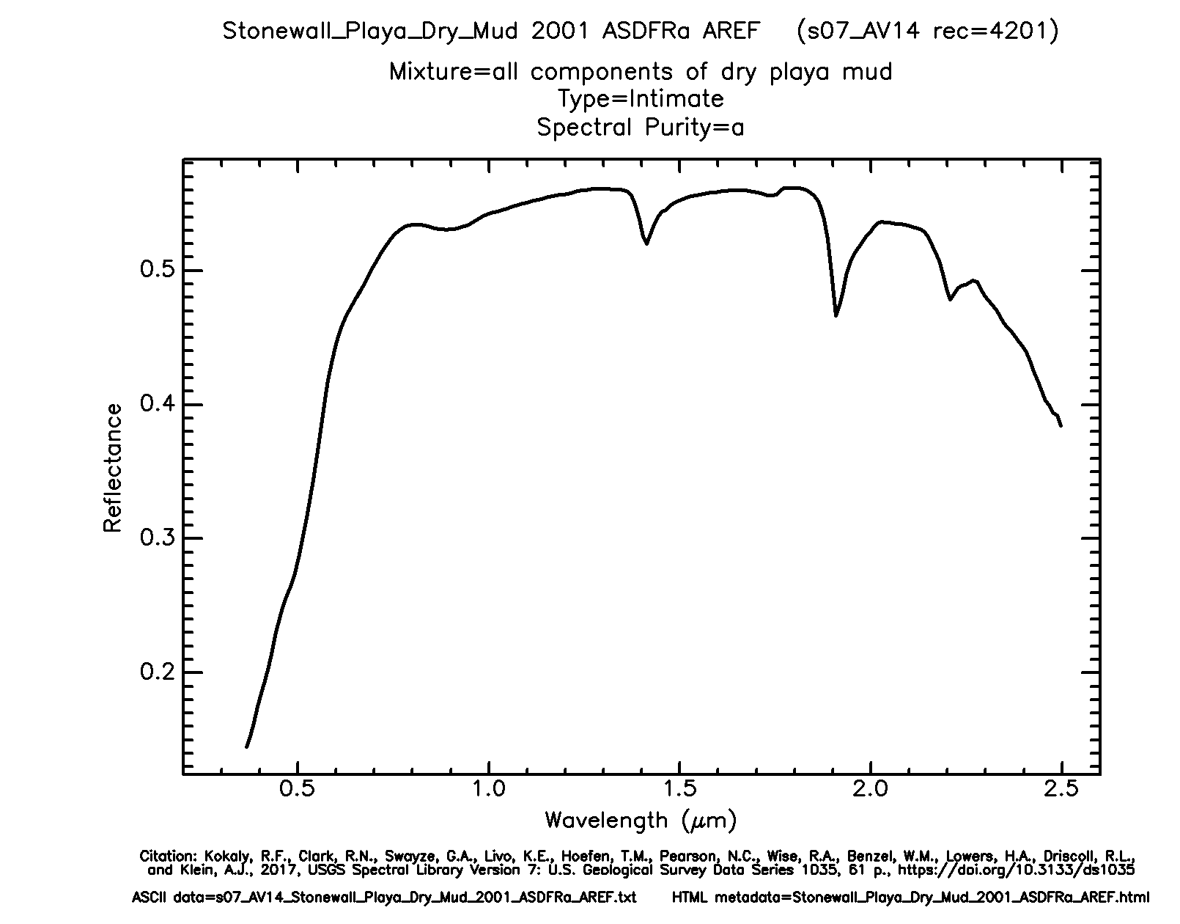

Figure 68: Landscape image and Stonewall Playa reflectance plot from the spectral library. Gif plot from USGS Spectral Library 7. Reprinted with permission. [9]

Unit with Sensor

Throughout the Everglades landscape, there are large, rocky pillars using one of several varieties of the Cliff mesh. It is assumed that these are made of sandstone, but sandstone is not included in the mineral data from the spectral library. Since sandstone is primarily composed of quartz, this mineral was selected for the pillars (Fig. 80).

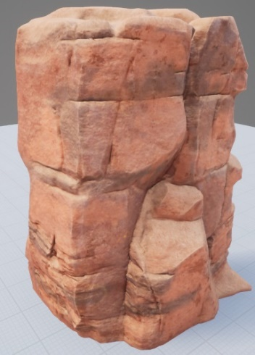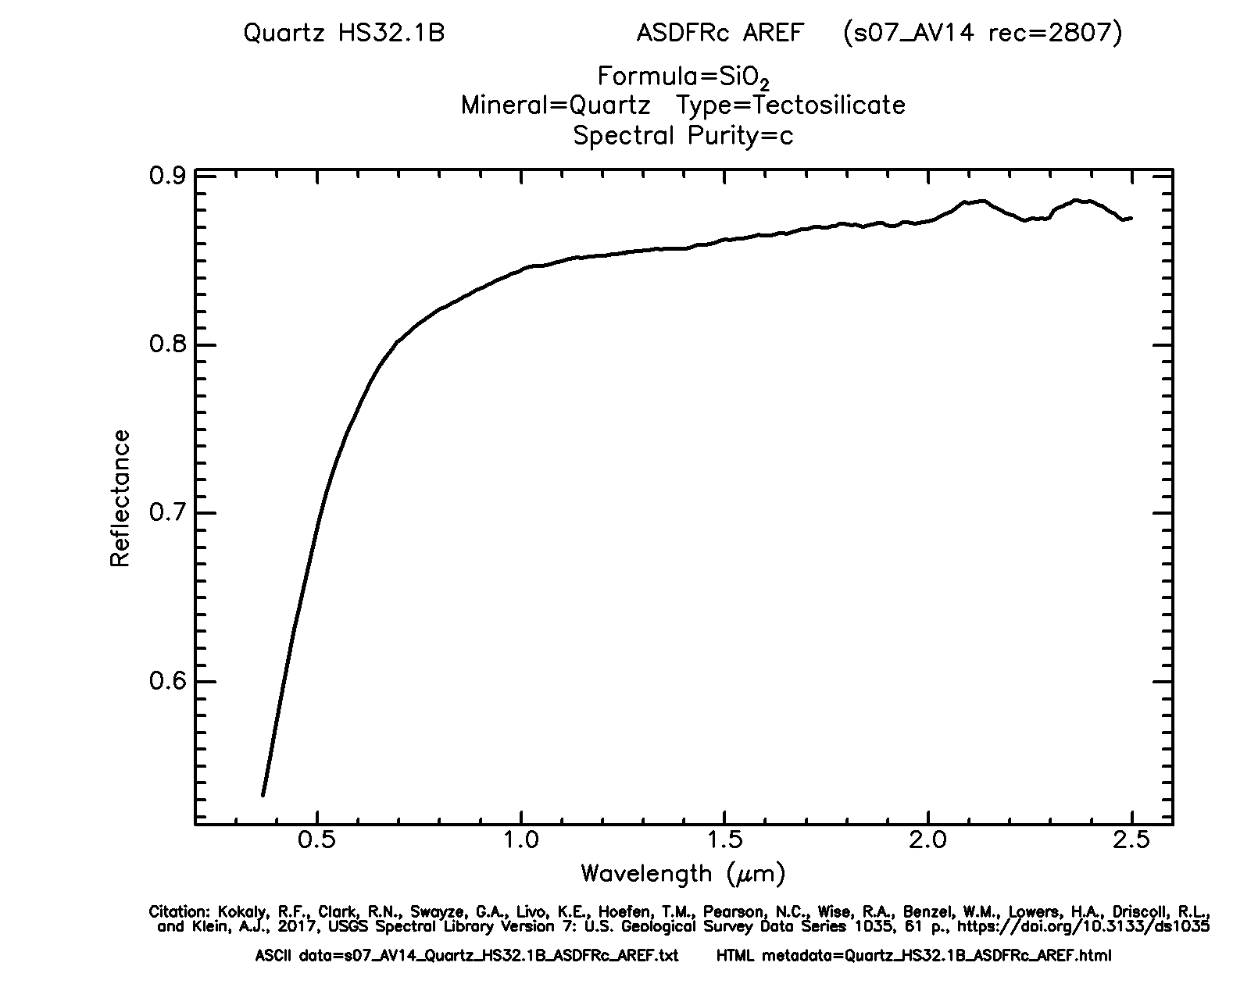

Figure 69: Cliff image and quartz reflectance plot from spectral library. Gif plot from USGS Spectral Library 7. Reprinted with permission. [9]

Flowing through the landscape is water that is assumed to be fresh and is represented by the Plane mesh. The spectral library does not contain data for pure water, but it does have data for water with dissolved montmorillonite, which is a clay. This would mimic dissolved sediments in the water (Fig. 81).

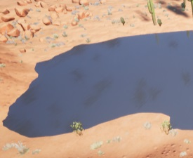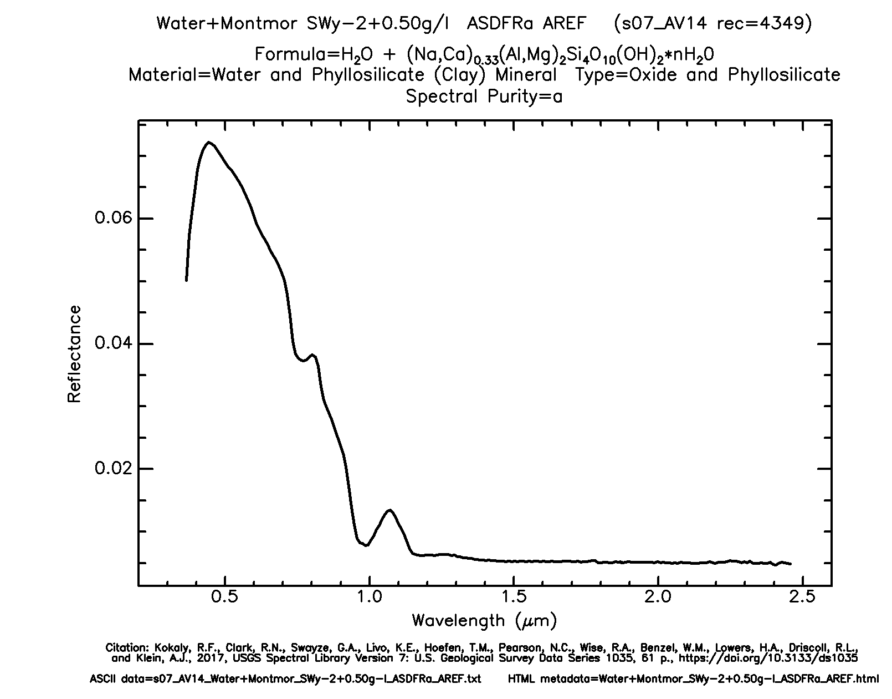

Figure 70: Plane (water) image and water + montmor 0.50 reflectance plot from spectral library. Gif plot from USGS Spectral Library 7. Reprinted with permission. [9]

Rocks are irregularly shaped. To distinguish them from other stones, goethite was chosen assuming its oxidation results in a reddish-brown desert color (Fig. 82).

Unit with Sensor

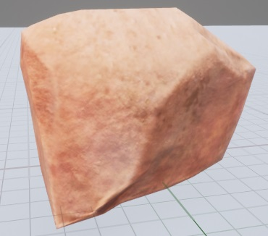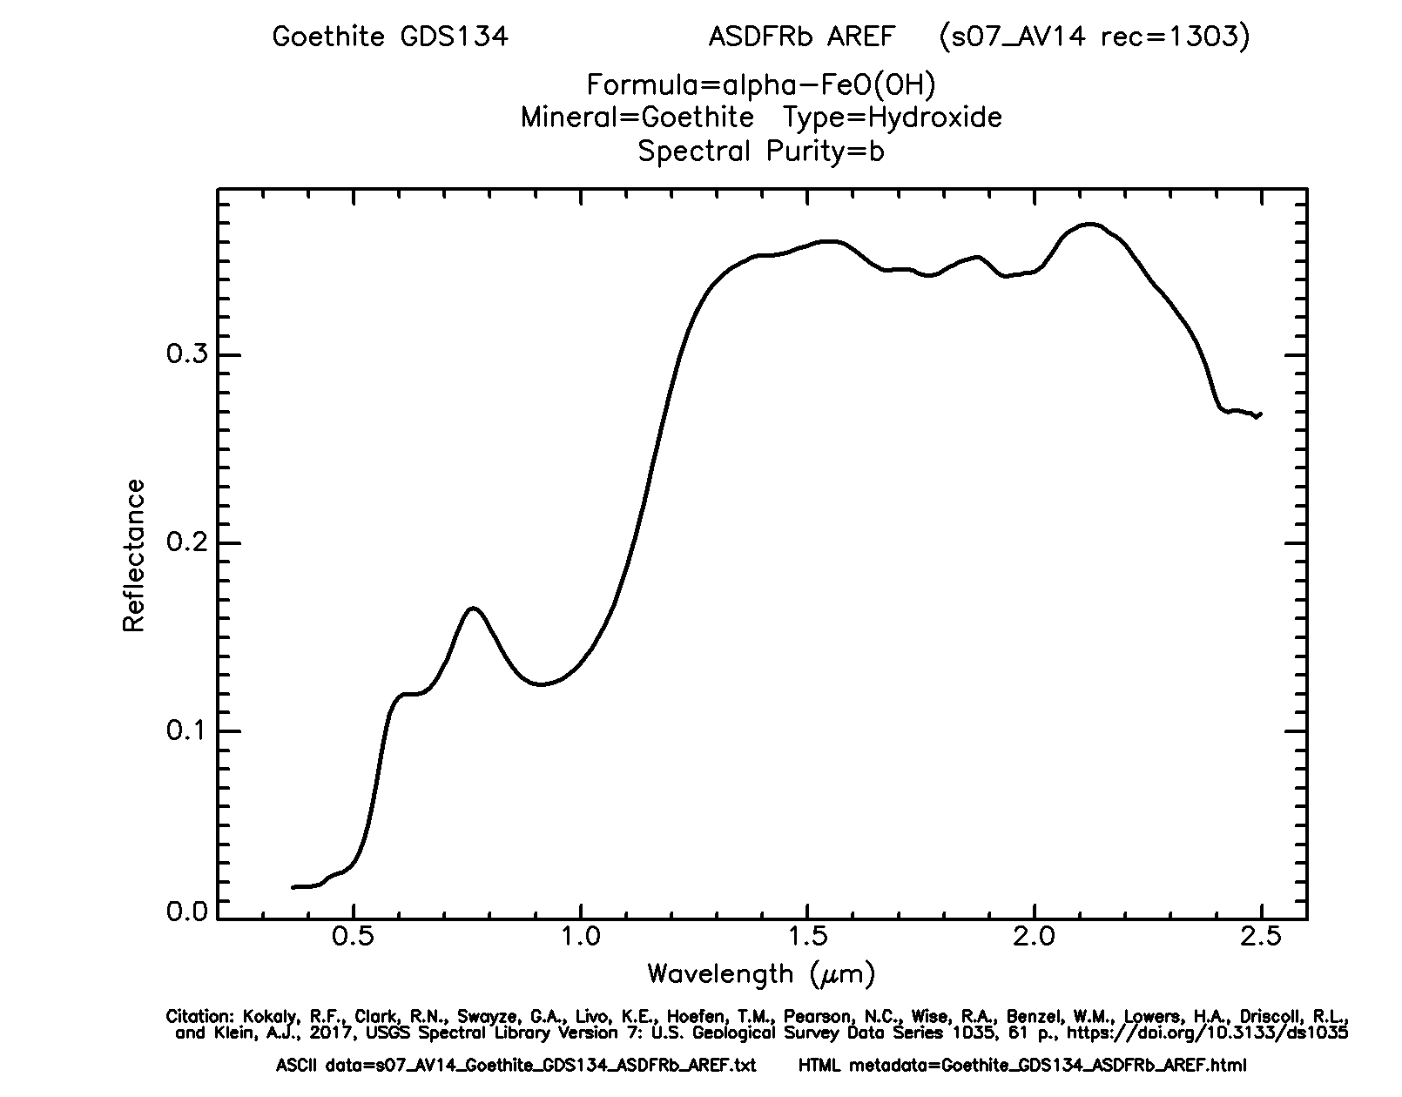

Figure 71: Rock image and goethite reflectance plot from spectral library. Gif plot from USGS Spectral Library 7. Reprinted with permission. [9]

RoundStones are like rocks but are rounded in appearance. They are assigned the mineral calcite, which can be found in some sedimentary rocks.

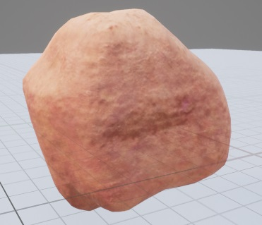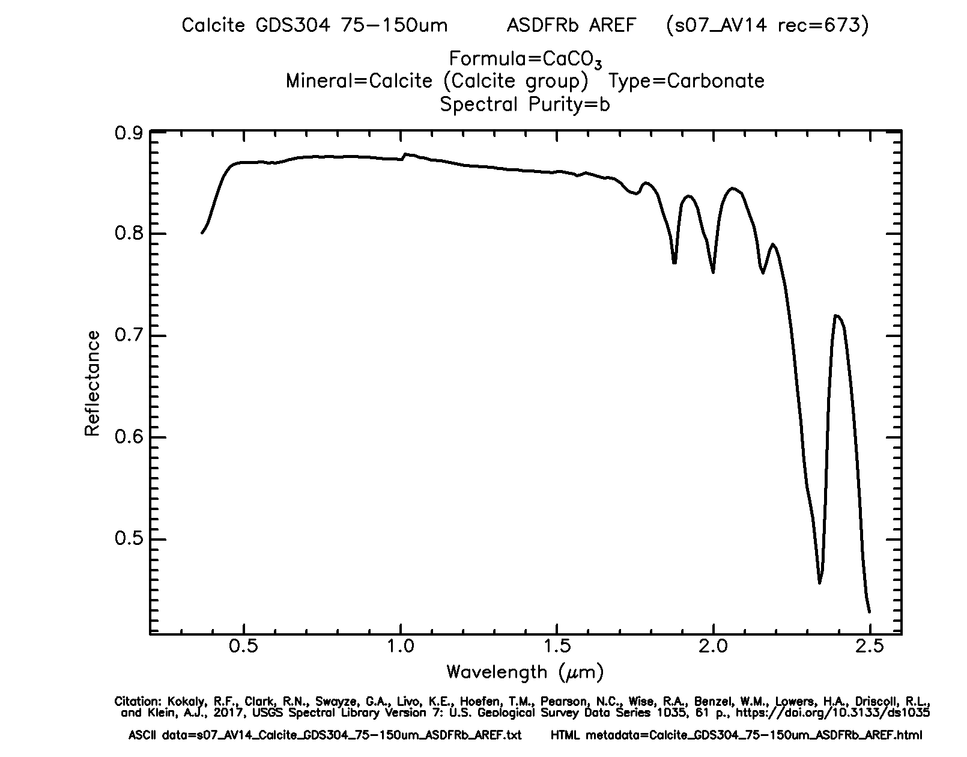

Figure 72: RoundStone image and calcite reflectance plot from spectral library. Gif plot from USGS Spectral Library 7. Reprinted with permission. [9]

BeamPad is the base of the center of a map node. They appear to be composed of concrete (Fig. 84).

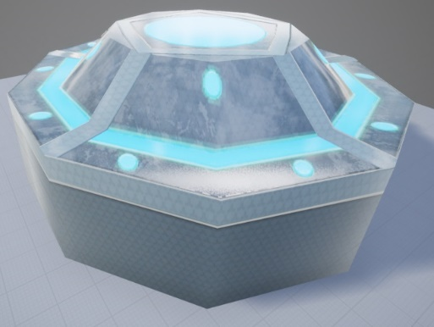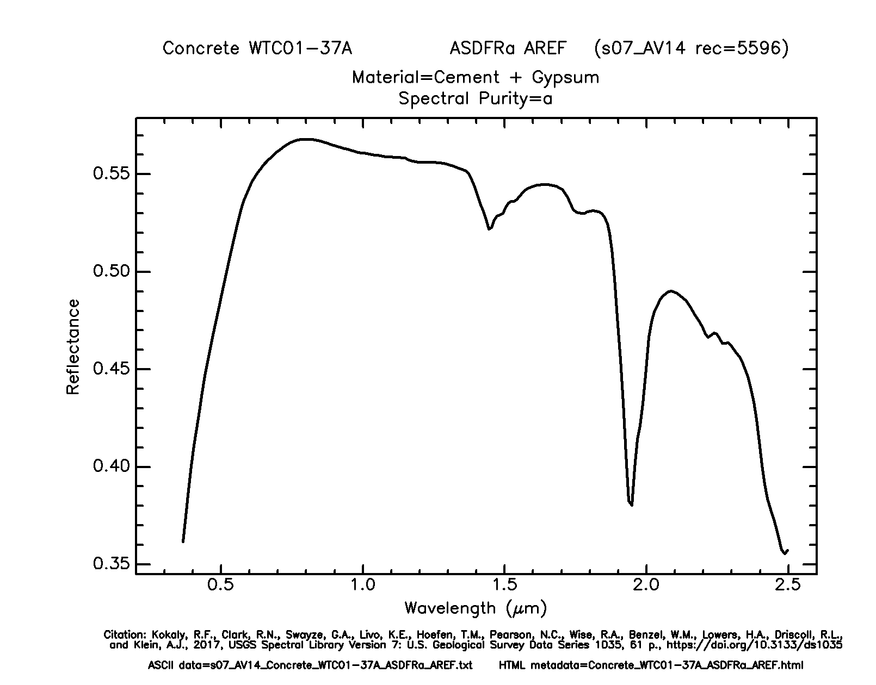

Figure 73: BeamPad image and concrete reflectance plot from spectral library. Gif plot from USGS Spectral Library 7. Reprinted with permission. [9]

Unit with Sensor

The walls surrounding each node are BasePiece1 and BasePiece2. They appear to be constructed of the same metallic material. Sheetmetal (without “galvanized” in the title) was selected as a representative.

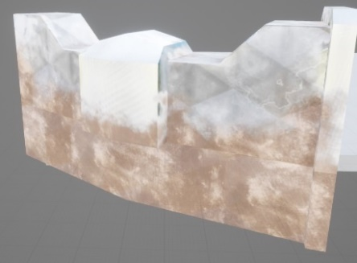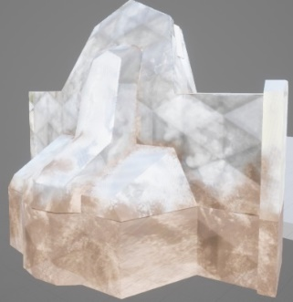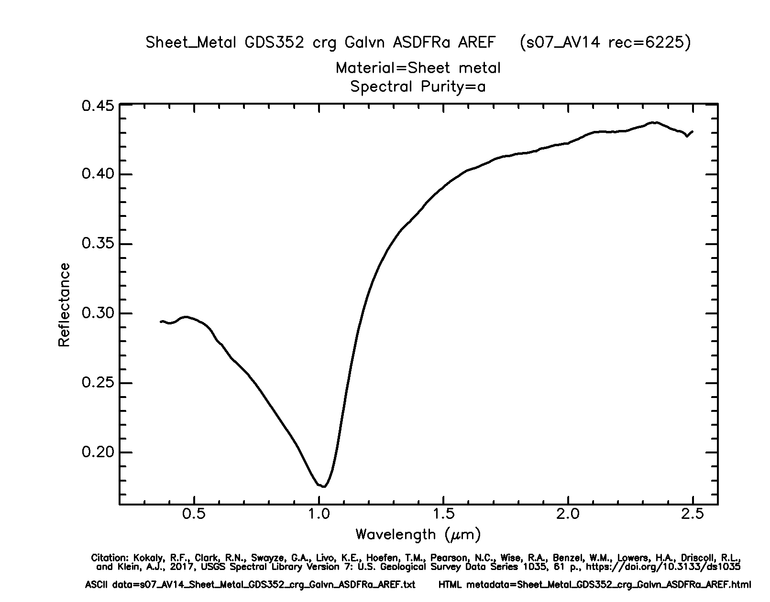

Figure 74: BasePiece1 and BasePiece2 images with sheet metal reflectance plot from spectral library. Gif plot from USGS Spectral Library 7. Reprinted with permission. [9]

The three types of units need some way to be differentiated when detected. This would provide the AI agents more information about the compositions of enemy groups that they come across. So, assumptions are made regarding the material of each type.

Strikers are the fastest but also have the least health. It is assumed that they are composed of a light material, such as plastic. HDPE plastic from the spectral library is a strong, but flexible plastic used in construction.

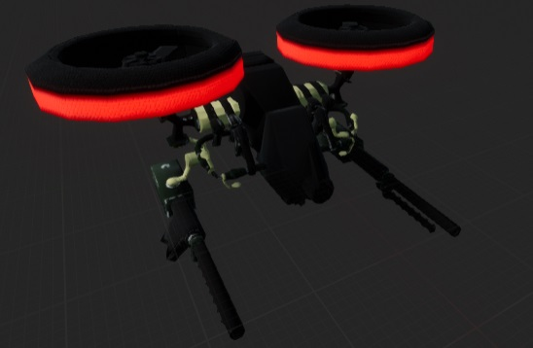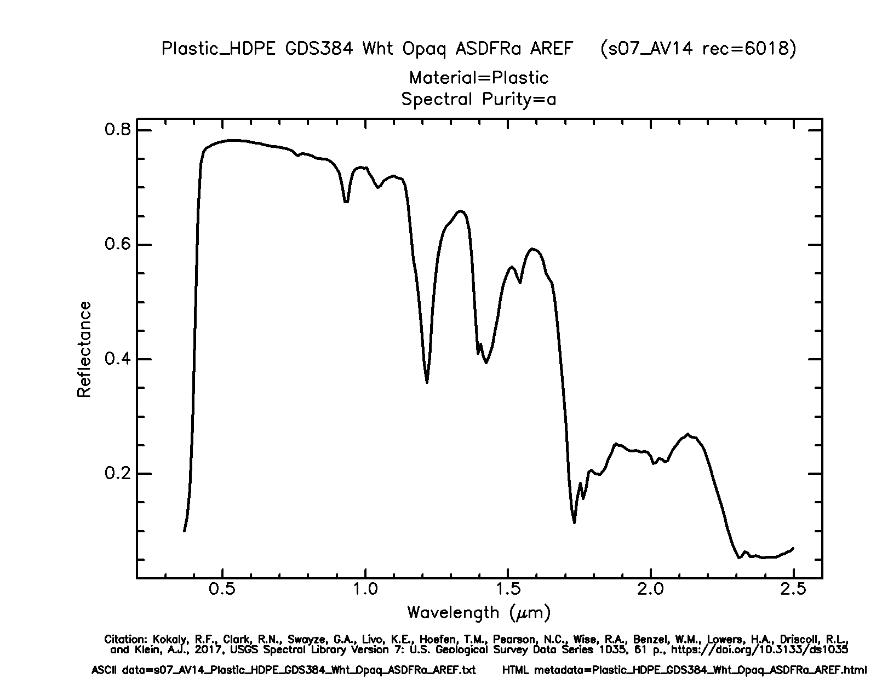

Figure 75: Striker unit image and HDPE plastic reflectance plot from spectral library. Gif plot from USGS Spectral Library 7. Reprinted with permission. [9]

Controllers have average health and are not as quick as strikers. A heavier, but robust material for them would be aluminum. The library only has data on brushed aluminum which is not ideal but can still be used.

Unit with Sensor

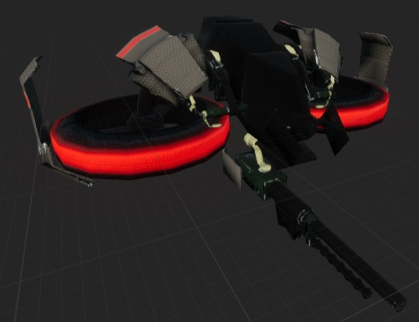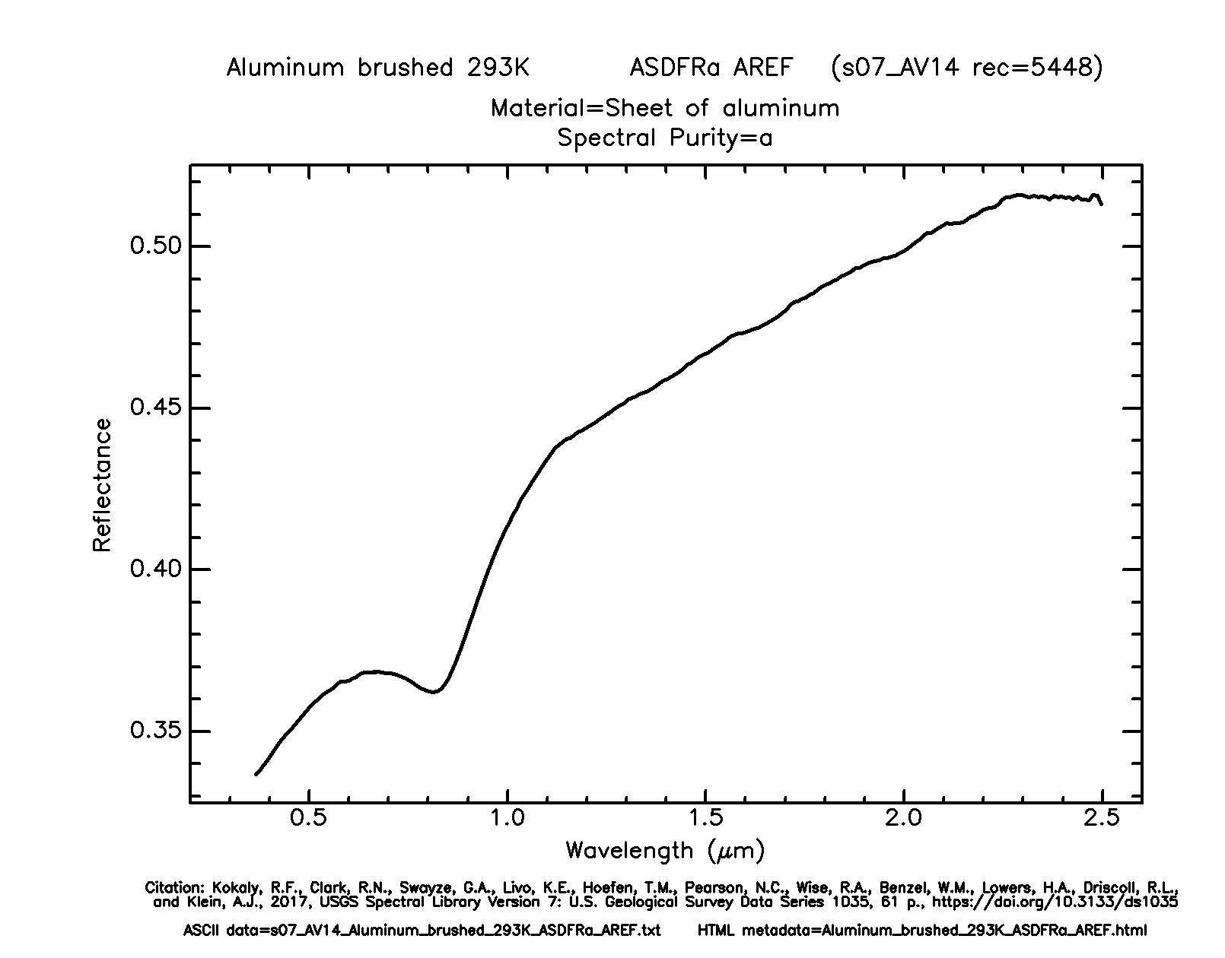

Figure 76: Controller unit image and aluminum reflectance plot from spectral library. Gif plot from USGS Spectral Library 7. Reprinted with permission. [9]

The tank has the most health of any unit. Despite moving at the same speed as the controller, it can be assumed that it is made of a stronger material. The spectral library contains galvanized sheet metal from a rain gutter. This is not the ideal material, but it will be assumed that the metal used for the drone would be thicker to provide “armor” to the unit.

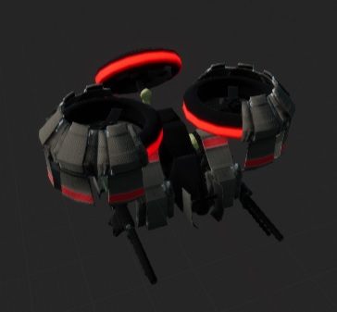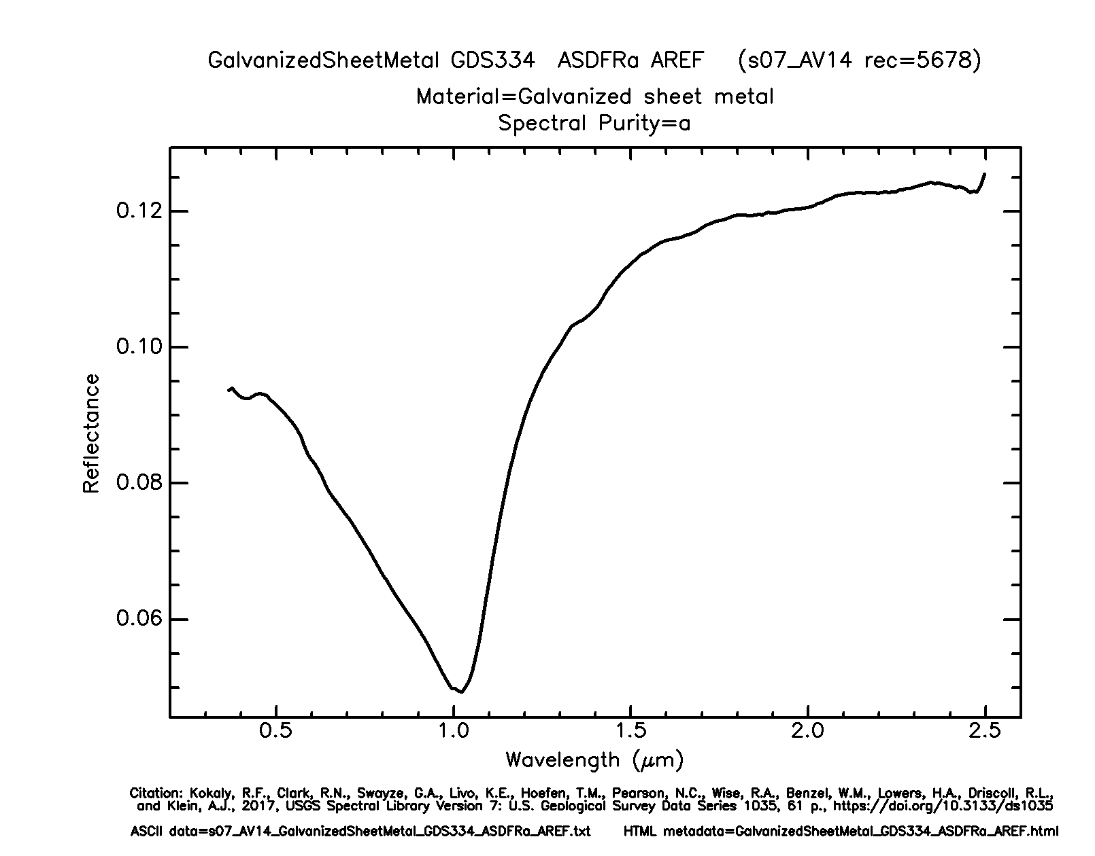

Figure 77: Tank unit image and galvanized sheet metal reflectance plot from spectral library. Gif plot from USGS Spectral Library 7. Reprinted with permission. [9]

Finally, the new recon unit is as fast as a striker and has the same amount of health. Thus, it will also be composed of plastic but PVC instead of HDPE to distinguish it.

Unit with Sensor

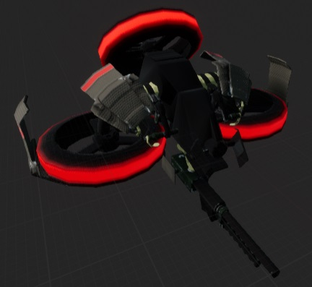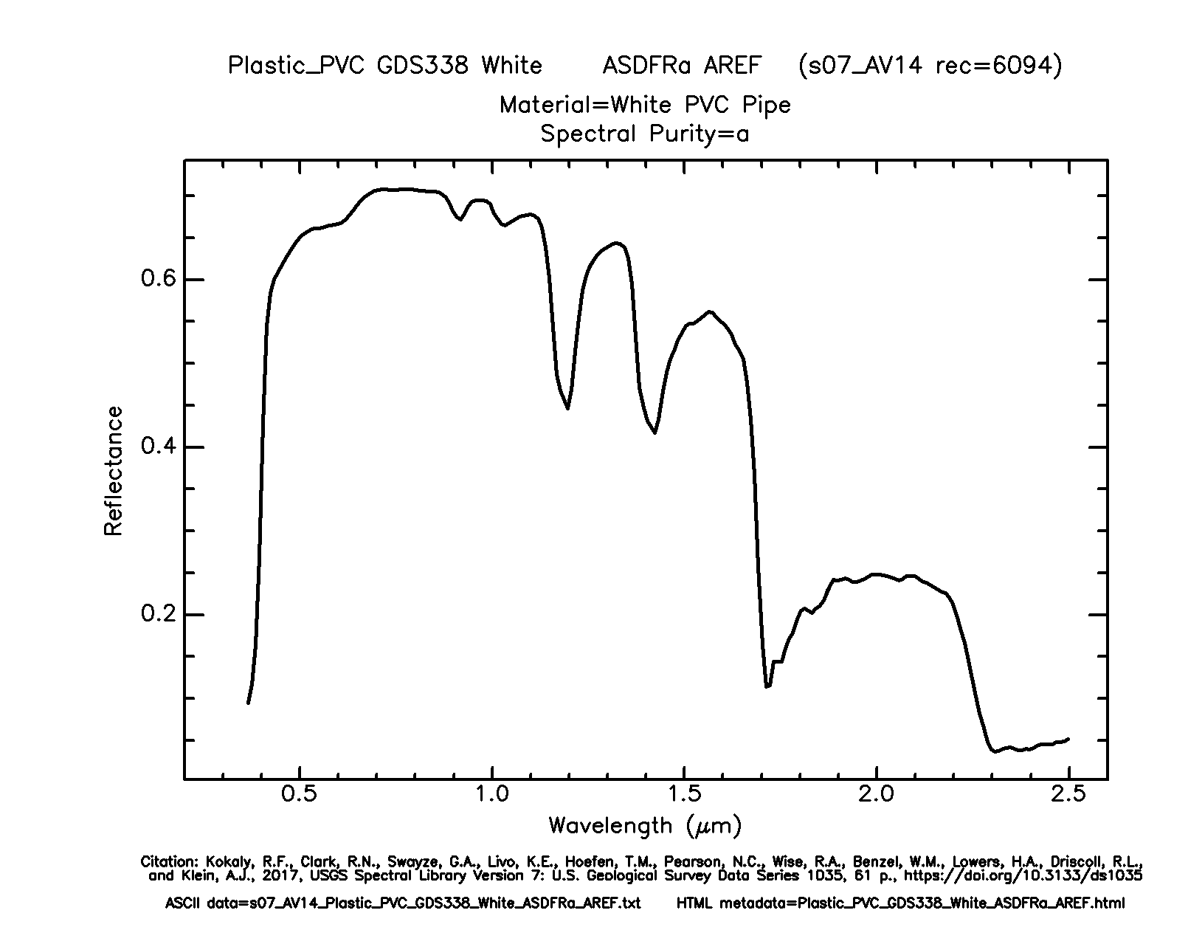

Figure 78: Recon unit image and PVC plastic reflectance plot from spectral library. Gif plot from USGS Spectral Library 7. Reprinted with permission. [9]

Sensor Configuration

Sensor configurations are passed to Unreal through the GROUP_Initialization telemetry file. These include the mode, range, wavelength, and adjusted speed for the recon units in the specified group.

Range determines the length of the shape trace and the maximum distance of objects it can detect. Passive sensor choice will use an object’s thermal data, while active will use the object’s reflectance data. Finally, the wavelength parameter is used to return a range of reflectance values. Currently, the values received are for the specified wavelength and the subsequent nine wavelengths, for a total of ten values. Fewer than ten values will be received if the provided wavelength is too near the end of the sensor range (i.e. a wavelength less than 10 rows from the end of the data table).

Thermal Image

Displaying the match in a thermal view would be a nice addition to the game, though it would not affect gameplay. This view can be toggled during playback by pressing the “2” key. Pressing this key enables a post-process volume which has its boundaries set to infinite and has a post-process material instance applied to it.

The material instance is derived from a thermal material blueprint. Being an instance, it allows a developer to set several parameters without needing to edit the blueprint directly. These parameters include the color gradient texture, minimum and maximum temperatures, object temperatures, and many scalar parameters to alter the thermal effect.

To develop this thermal vision, first, a thermal color gradient needed to be created (see figure 8). This gradient can be created in photo editing software, such as Photoshop. In the interest of cost, it will be created with GNU Image Manipulation Program, which is free. Inside Unreal, it can be applied to individual objects and even the whole scene.

Unit with Sensor



*Figure 79: Thermal gradient*

Specific objects and the scene are differentiated by using a custom depth with stencil values. These stencil values allow different objects to be differentiated and have different color values applied to them according to their temperature (Fig. ). The objects in Everglades need to be exposed to a custom depth pass and assigned an integer for their stencil value.

Figure 80: Everglades game world showing some stencil values.

A post-process material was created and contains the logic of this thermal vision effect. The material takes the stencil value for the object and normalizes it based on the minimum and maximum temperatures. It passes this value as a uv coordinate to the thermal gradient texture to choose a color representing that object. This color is then passed to a Fresnel function. Fresnel materials utilize dot product to calculate surface normals. Those facing directly toward the camera have a value of 0, while those perpendicular have a value of 1. This creates a falloff effect (see figure 9).



*Figure 81: Fresnel material in Unreal Engine*

The final step is to apply a panning noise texture that adds some distortion to the thermal vision. The final effect can be seen in Figure .

Unit with Sensor

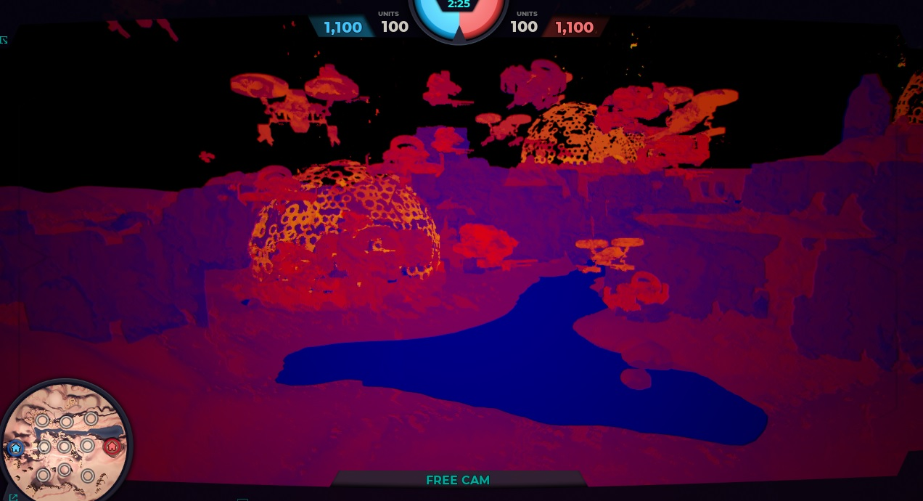

*Figure 82: Thermal effect*

Cost/Benefit of Reacting to Sensor Data

With the new unit able to gather data on the positions of other units and bases, a decision needed to be reached for how this unit would react to this information. This reaction could occur either during the game as part of the unit’s game logic or could be presented to the AI agents for them to decide. A cost/benefit analysis was necessary to reach a decision on implementation.

The first option would involve having the recon unit react during the game itself, with the logic occurring inside of the game. This could allow more interesting obstacles for the AI agents, depending on how the game or units reacted to the information. Perhaps the recon unit would retreat or maybe it would alter unit movements based on its knowledge of enemy units. As interesting as this could become, it is not very realistic because the recon unit should not be commanding the other units. Additionally, implementing an idea like this could require large changes to the existing game and there simply isn’t enough time to complete it.

The second option would merely collect the data and make it available to the AI agent that collected it. The decision on any course of action would occur within the AI logic. This solution makes much more sense because the recon unit merely collects data and has no knowledge of where other friendly units are located or any other strategic information. That is the job of the AI

agent. So, it would be interesting to see how a user programs an agent to use the data that the recon units collect.

Player Selection of Drone Types

Currently, the Everglades project has predetermined units for each group in a player’s arsenal. A worthwhile addition to the Everglades game state is the ability to allow a player to choose their own units for a group. The implications of this in an AI driven game are substantial. Giving an agent the ability to choose their own units will result in them being more sophisticated.

According to the telemetry data found in “Group_Initialization”, each group is given predetermined groups of Controllers, Strikers, and Tanks. Each group is homogenous, meaning groups at this point only contain one type of unit, due to a bug. Another thing to mention is that each player possesses the same groups with the same units.

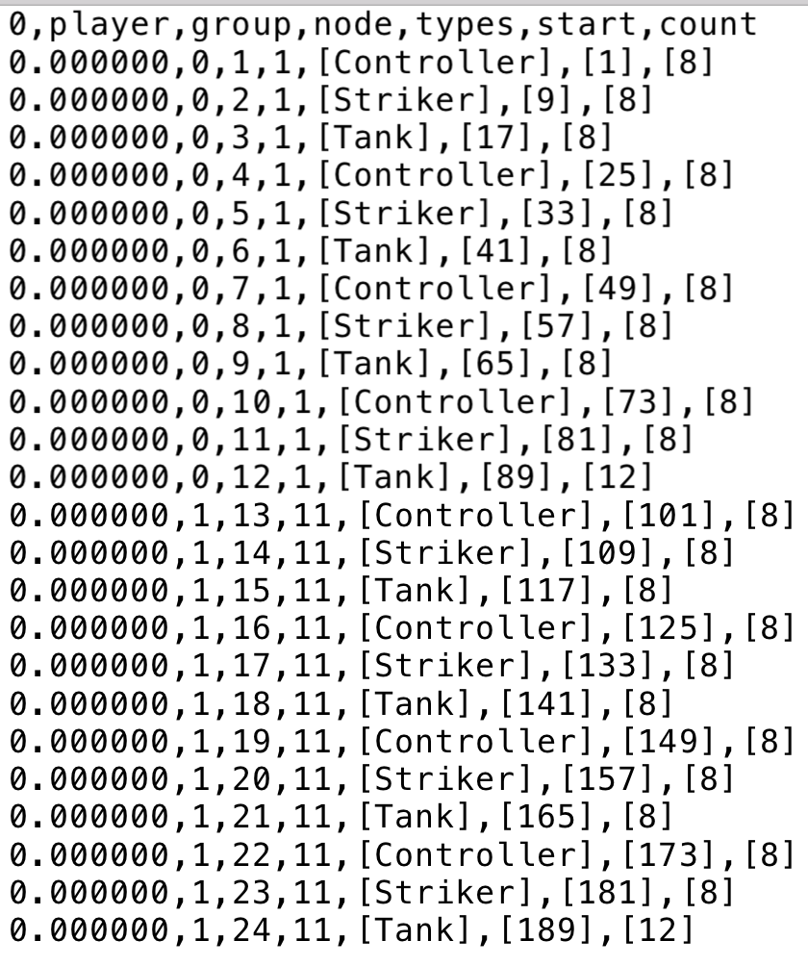

Figure 83: Group Initialization Telemetry Data

The code for group generation can be found in the “game_init” function found in the “server.py” file in the Everglades code. Currently, it simply cycles through the defined in the Unit Config JSON file and adds a certain number of units to each group. Judging by the telemetry data above, that amount seems to be 8 units per group and then a single group of tanks with 12.

Player Selection of Drone Types

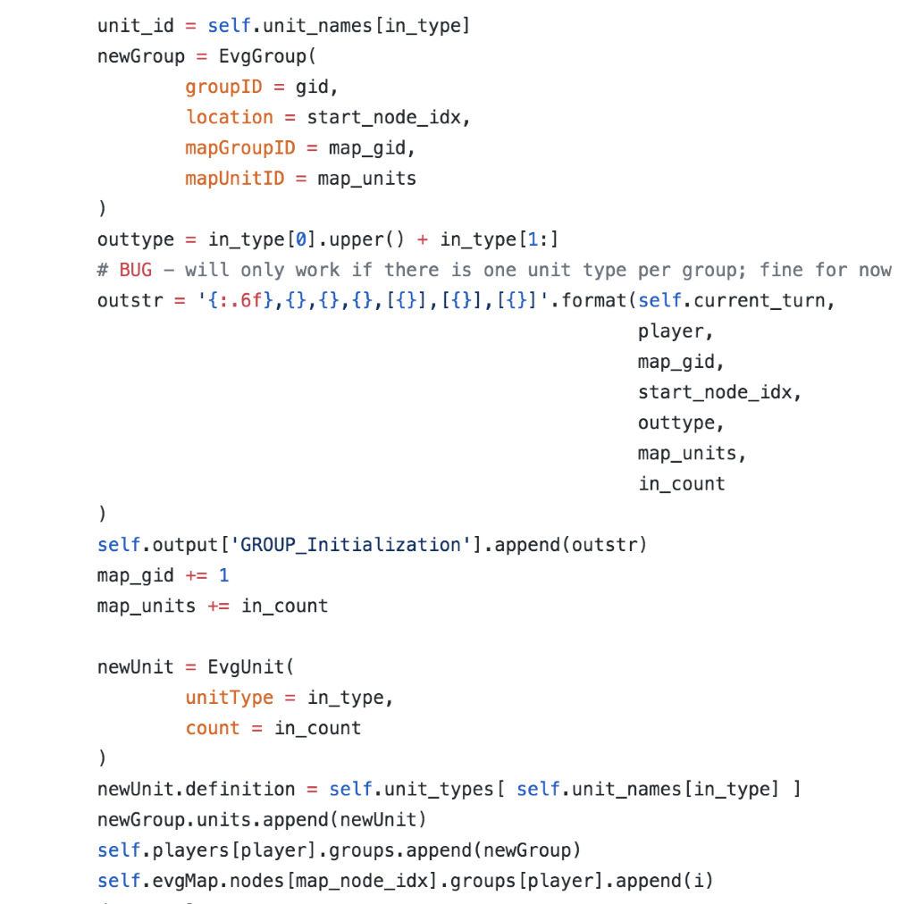

Figure 84: Excerpt from game_init function for group initialization

Player Selection of Drone Types

Currently, there appears to be an unused file that is geared towards allowing a player to decide their own groups, this code is found in the “PlayerConfig.json” (Fig. ). This file solely exists to initialize the groups belonging. to the player. Most likely what occurred is that previous developers of the project had just begun developing this feature and could not getting it working correctly. The potential use of this file was abandoned in the current project. Instead, the custom group configurations are passed by the agents themselves, though the previous method for creating groups is used as a default if no custom configuration is provided.

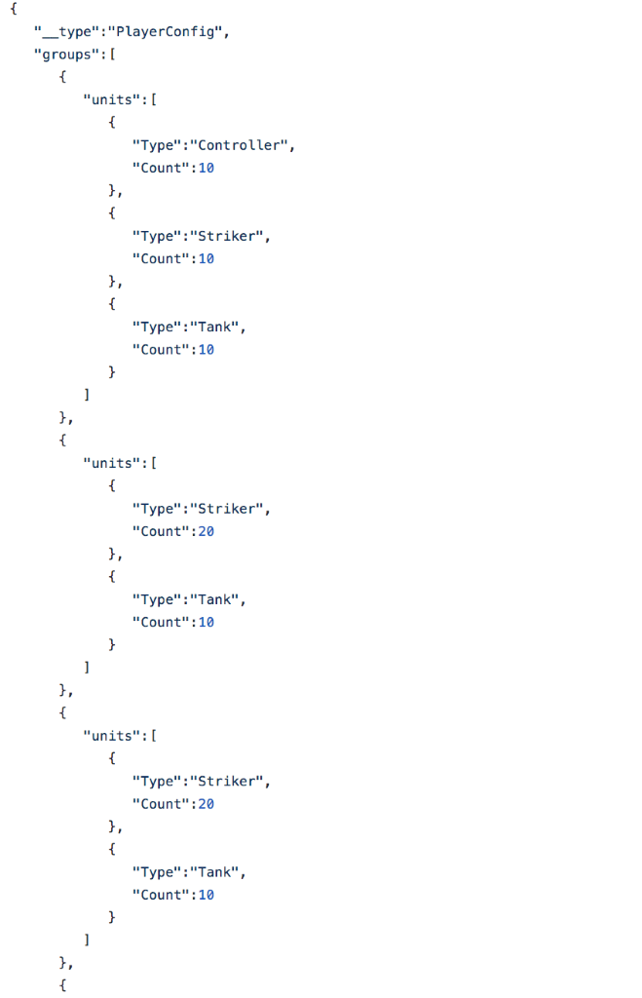

Figure 85: Excerpt from PlayerConfig file

Testing

Unit, Integration, and Functional Testing

According to [13], any software application, testing is important step of development that makes sure that parts of a product are working as intended on their own and with other modules. In developing the Everglades game environment, two types of testing will be performed: unit and integration testing.

Unit Testing

Unit testing involves testing individual modules of an application in an isolated environment. This means that the module is run without any interactions with dependencies to confirm that the code is executing correctly, and that the logic is sound. Unit tests are overall easier to write and quicker to execute.

Integration Testing

Integration testing involves checking if different modules are working together correctly. This type of testing is usually done after sufficient unit tests on each individual module have been performed.

Functional Testing

Functional testing is a black box testing technique where the functionality of the application is tested to generate the desired output when providing a certain input. Functional testing is the most time-consuming and most infrequent type of software testing.



*Figure 86: Test case frequency pyramid [12]*

Testing

The above Figure outlines the general frequency and cost of each type of testing. As shown in the diagram, unit tests are the most frequent type of test case and the least expensive, integration testing follows by having fewer total tests and costing more to run, and functional testing costing the most and having the least amount of test cases.

Testing Strategy

A **big bang** integration testing approach will be implemented for developing the game portion of the Everglades project. In a big bang approach, all modules or units are integrated and tested as a whole at once. The major advantage of using this kind of testing is that everything integrated is tested at one time.



Figure 87: Diagram for Big Bang Approach [12]

The three main modules for unit testing will adhere to the main objectives of the project. In other words, the modules will be procedural board generation, stochastic wind seeding, and new unit generation. Each of these modules will first be tested individually through unit testing to make sure that their logic is sound. Then the tested units will be implemented into the game server to make sure that they’re working in conjunction with the other units. The reason that a big bang integration testing method is going to be used on this project, is because there are only three members in the group. This means that it should be easier to test all the units at once, since there are less units to test when compared to a group of five or more.

Testing

Performed Unit Testing

Stochastic Wind Generation

* Making sure that seeds produce consistent values when returned
* Confirming that each node in a list
* Testing to make sure that a wind value is correctly being added to the telemetry data
* Making sure that wind modifier is correctly effecting unit movement speed
* Testing to make sure generated numbers are correctly being transformed into percentage modifier

Procedural Game Board Generation

* Ensuring only valid maps are generated
* Testing game initialization to make sure the generated map is loaded correctly into the main application procedure
* Checking telemetry data to see if all nodes of the random map are being processed correctly
* Ensuring the generated map is included in the final telemetry data output

New Unit

* Making sure that each attribute of the unit such as health and speed are initializing correctly.
* Making sure its sensor ability works correctly with back-end python code
* Testing that changing sensor configuration correctly affects the sensor in the game.
* Making sure that sensor ability works correctly with front-end Unreal code by testing functionality in Unreal example.
* Testing that thermal vision correctly appears in Unreal and is only active when a thermal vision camera is used. Otherwise, scene should appear normal.
* Testing to make sure that unit is correctly implemented in the JSON configuration file.

References

[1] Jain, Preeti. “Infrared Sensors or IR Sensors.” (2 January 2012) Engineers Garage. retrieved from <https://www.engineersgarage.com/article_page/infrared-sensors-or-ir-sensors/>. 12 Oct 2019

[2] “What is Synthetic Aperture Radar (SAR)?” Sandia National Laboratories. retrieved from <https://www.sandia.gov/radar/what_is_sar/> 13 Oct 2019

[3] Mühlbauer, Stefan. “Moving objects and their displacement in SAR images.” (10 April 2016) Geo Awesomeness. retrieved from <https://geoawesomeness.com/moving-objects-and-their-displacement-in-sar-images/> 13 Oct 2019

[4] “Correlation Between Temperature and Radiation.” Climate Science Investigations. retrieved from <http://www.ces.fau.edu/nasa/module-2/correlation-between-temperature-and-radiation.php>

on 19 October 2019

[5] “Ir girl”. [Cody.pope](https://en.wikipedia.org/wiki/User:Cody.pope). Wikimedia Commons <https://upload.wikimedia.org/wikipedia/commons/c/cf/Ir_girl.png> retrieved 19 October 2019

[6] “15ftSARimage”. Oldteched. Wikimedia Commons. [https://upload.wikimedia.org/wikipedia/commons/b/bb/15ftSARimage.JPG retrieved 19 October 2019](https://upload.wikimedia.org/wikipedia/commons/b/bb/15ftSARimage.JPG%20retrieved%2019%20October%202019)

[7] “Sarresrp”. [Dantor](https://commons.wikimedia.org/wiki/User:Dantor). Wikimedia Commons. <https://commons.wikimedia.org/wiki/File:Sarresrp.jpg#file> retrieved 16 October 2019

[8] ribbons. Epic Games. <https://docs.unrealengine.com/en-US/Resources/ContentExamples/EffectsGallery/2_E/index.html> retrieved 20 October 2019

[9] Kokaly, R.F., Clark, R.N., Swayze, G.A., Livo, K.E., Hoefen, T.M., Pearson, N.C., Wise, R.A., Benzel, W.M., Lowers, H.A., Driscoll, R.L., and Klein, A.J., 2017, USGS Spectral Library Version 7: U.S. Geological Survey Data Series 1035, 61 p., <https://doi.org/10.3133/ds1035>

[10] Medium.com. (2019). *Playing with Perlin Noise: Generating Realistic Archipelagos*. [online] Available at: https://medium.com/@yvanscher/playing-with-perlin-noise-generating-realistic-archipelagos-b59f004d8401.

[11] “Correlation Between Temperature and Radiation.” Climate Science Investigations. retrieved from <http://www.ces.fau.edu/nasa/module-2/correlation-between-temperature-and-radiation.php>

on 19 October 2019

References

[12] Softwaretestinghelp.com. (2019). *The Difference Between Unit, Integration and Functional Testing*. [online] Available at: <https://www.softwaretestinghelp.com/the-difference-between-unit-integration-and-functional-testing/>.